BULLETIN INFORMATION FOR HEADTEACHERS

- Our first CASH Conference of the 2023-24 academic year at Lanhydrock Hotel and Golf Club. programme is here – see Word INSERT. Thank you so much for your responses and support of CASH activities; we have 40 colleagues joining the conference next Friday, and…  - …simply for information, we had our first subject leaders meeting yesterday morning - 25 colleagues joined the Maths subject leaders meeting yesterday when the AQA Curriculum Manager joined us face to face having travelled from Manchester. Darren White (Humphry Davy) and Debbie Bland (Truro College) also gave presentations and CPD details as the 11-16 and post 16 CODE Maths Hub leads, too. (Our Maths Hub, CODE, is Cornwall, Isles of Scilly and some of Devon & Plymouth)! We are also able to access CPD through the neighbouring hub, Jurassic which is often more geographically convenient for colleagues in North Cornwall.  ITEMS THAT WERE IN LAST WEEK’S BULLETIN – they will disappear next week!  - The Big Ambition was launched yesterday by Dame Rachel de Sousa, Childrens’ Commissioner.    “Today [Thursday] I have launched ‘The Big Ambition’ survey to hear directly from children, young people, and parents across the country. I want to hear about what they enjoy about their schools, communities, family life, and the wider world. I also want to know what they want for their future, their hopes and their aspirations…” |   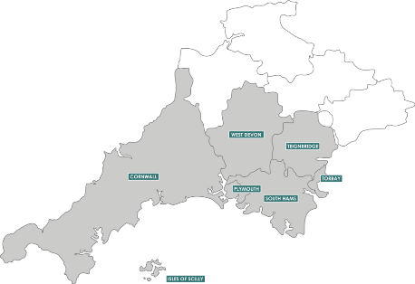    News from the Children's Commissioner for England - Launch of The Big Ambition! (mailchi.mp)  Full details on link.
DISCUSSION POINTS & DEBATES OF THE DAY

Two reports of interest were published yesterday.  - The first, regarding societal attitudes to school attendance post pandemic makes sobering reading and is widely reported across the media – reaffirms much of what we are seeing in Cornish schools; a useful pre-read for the CASH conference next Friday. The INSERT is the TES summary which includes a link to the full report which also makes some policy recommendations for government.  - The second has been less widely reported, and is a University of Oxford investigation into the impact of covid and lockdowns on secondary school aged young people’s mental health. The ‘monteromarin’ INSERT is the full 16 page research report, and the first link is the University of Oxford summary. I have also included the Guardian’s report of it which is where I spotted it.  “This study shows that to promote better mental health and adjustment among young people, we need policies that foster home connectedness, friendship and a positive school climate that consider young people’s individual differences, needs and vulnerabilities.” (Prof Willem Kuyken) | Full report:  Summary report: Young people’s mental health deteriorated at greater rate during the pandemic | University of Oxford  The Guardian article: https://www.theguardian.com/society/2023/sep/21/mental-health-among-uk-secondary-pupils-worsened-sharply-in-pandemic-study-shows?CMP=Share_iOSApp_Other
BULLETIN INFORMATION FOR HEAD’S PAs

INFORMATION SHARED WITH SUBJECT LEADERS (FYI)

- One subject report published by OfSTED this week will be circulated to subject leaders today: Music.  - Physical Education subject report has also been published. I don’t have a contact for all PE subject leads – please could I ask PAs to forward this accordingly.  Following Maths yesterday at Brannel, three subject leaders meetings will take place between now and half term: History (at Helston) on 3rd October, 9.30am start; Geography (at Wadebridge) on 13th October, 9.30am start and Science (at Penair) on 18th October, 2.00pm start. Other subject meetings take place on 31st October (English at Helston) and throughout November.  The 11-18 schools Heads of Sixth meet on the afternoon of 10th October at The Atlantic Centre, Newquay. | Striking the right note: the music subject report - GOV.UK (www.gov.uk)  Levelling the playing field: the physical education subject report - GOV.UK (www.gov.uk)
ADVANCE NOTICE OF STAFF/GOVERNOR TRAINING, STUDENT AND OTHER EVENTS

These events are listed chronologically and  will only disappear once they have happened!  - The LA are hosting a Governance conference next weekend on Saturday, 30th September at Brannel. Details on the flier INSERT.  - Safer Cornwall are hosting a one day conference at the Pavilion Centre, Royal Showground, Wadebridge on Wednesday, 11th October focussing on preventing domestic abuse and sexual violence. Details on the flier INSERT. | Governor Conference 2023 flyer.pdf  CIOS DASV VAWG conference 2023 flyer.pdf


David Barton
CASH Executive Officer
07980719597
dbarton@cornwallsecondaryheads.co.uk

