BULLETIN INFORMATION FOR HEADTEACHERS

- The DfE have published details for the National Tutoring Funding for 2023-24, the last year of the scheme. Three links: the DfE guidance; the DfE press release announcing that the government will now pay 50%; and, the funding calculators.“The academic year 2023/24 is the fourth and final year of the NTP. We hope you will use this final year of NTP funding to consider how you will deliver and fund tutoring in your school in the future. We want tutoring nevertheless to continue into the long term, providing targeted support for those children who will benefit. We are also considering how we can support delivery of this long-term ambition.”  - The DfE published updated Suspensions and Permanent Exclusion guidance yesterday, to come into effect w.e.f.1st September 2023; Part 2 of the guidance explicitly states the changes that have been made…  - …accompanying this guidance is a newly published guide for parents on school behaviour and exclusions. (I expect that the DfE will publish a more user friendly blog on this subject, but haven’t as yet).  - Black Voices Cornwall have produced resources including an assembly video (up to 30 minutes) for secondary schools to recognise the 75th anniversary of The Windrush coming to Britain (there is a separate primary school package and assembly). The poster and links/QR codes to request access to the materials is also embedded in the Word INSERT which includes contact details and more information.  - The Cornwall Area SEND Inspection report has been published – see link.  - I received an email from Fatma this morning thanking the dozen schools that have already completed the survey re sustainable food – thank you! I am also delighted that following contact with her from yourselves, she has arranged meetings with two schools and local farms already!  - Cornish Stories of Survival is a project that has been ongoing over the last couple of years focussing on Cornish survivors of the Holocaust, and schemes of work have been developed by RE and History colleagues at Torpoint and Penryn respectively. Throughout its development I have been liaising regularly with your RE and History subject leaders, but as we move into the third year there is a broadening out of the curriculum areas that may potentially be keen to become involved. There is a second annual conference in July to which school leaders are invited, and please feel free to share as widely across your school as you wish – RE, History and Art subject leads have already received this information and I shall copy this item to English subject leads, too. Graeme Plunkett is building the programme into Curriculum Kernewek and PSHE subject leads will be introduced to the project at their summer workshops, hosted by Graeme and the effectiveness team.  - International Refugee Week runs from 19th-23rd June. There is an education specific event for Cornwall’s school leaders on the afternoon of 20th June; “Compassion into Action: The Role of Schools in Cultural and Community Leadership” at Royal Cornwall Showground, Wadebridge. | National Tutoring Programme: guidance for schools, academic year 2023/24 - GOV.UK (www.gov.uk)  Government to match schools’ tutoring costs next year - GOV.UK (www.gov.uk)  Three funding calculators have also been updated this week – mainstream schools; special schools; and mainstream with an SEN unit:  National Tutoring Programme calculator tool: 2023 to 2024 - GOV.UK (www.gov.uk)  School suspensions and permanent exclusions - GOV.UK (www.gov.uk)  A guide for parents on school behaviour and exclusion - GOV.UK (www.gov.uk)    50215730 (ofsted.gov.uk)  The survey link is here: https://exeterssis.eu.qualtrics.com/jfe/form/SV_56CGHClOn1J5dfE  Or, if you prefer here is a barcode access to the survey:    Refugee Week – 19th – 25th June 2023  Link to book for the Wadebridge showground event:  Training and Events | Cornwall Services for Schools  Use Code CON1
DISCUSSION POINTS & DEBATES OF THE DAY

The debate around the future education landscape continues, and this week two articles in particular caught my eye:  1. An excellent think-piece published by FED advocates a complete reset of education policy and thinking. “In another 50 years’ time researchers of educational history will be hard pressed to decide which period of the last 50 years turned out to be the most productive in terms of translating political intent to an effective reality…Too often the status of ‘education expert’ is awarded to those who have simply established themselves as education ‘influencers’ with strong political links but with little substantive evidence of impact…The perpetual lag between education and the societal and technological changes affecting it has grown and it is now approaching a chasm. The policy response has been to double down on increasing centralisation and consequent direction. As a result, children and young people in state education are becoming more and more disconnected. Meanwhile the economic costs of such alienation grow exponentially.  2. TES published an article by Leora Cruddas, Chief Executive at the Confederation of School Trusts (CST). “We cannot limp on indefinitely with a fragmented system…[but] I do not believe that it is desirable for this government - or, indeed, any government - to determine a grand plan that reorganises state schools. And I don’t think the sector would accept it if there was one.” | Education in England needs a ‘re-set’ – a practitioners’ view and a call for action – FED Education  “Education in England needs re-imagining because of years of increasingly chaotic government, the self-infliction of ‘grade inflation’, questionable changes, likely disruption to teacher training and present funding issues which highlight that the system is simply not fit for purpose for young people and new societal demands. The system needs re-purposing and a new design.”  Authors: Tom Clark CBE,  Dame Kathryn August and  Tony MacKay (Centre for Strategic Education, Melbourne, Australia).
BULLETIN INFORMATION FOR HEAD’S PAs

ADVANCE NOTICE OF STAFF/GOVERNOR TRAINING, STUDENT AND OTHER EVENTS

These events are listed chronologically and  will only disappear once they have happened!  - The LA are again running PSHE workshops this summer; feedback from last year’s sessions was very positive. There are four sessions in June, two in Bodmin and two in Truro, you only need to attend one! The workshops will include content on vaping and social media/influencers. Full details and booking on the INSERT.  - Penryn College are rapidly moving toward the end of Year 2 of a national Creative Collaborative project; on June 12th the college is hosting an end of Year 2 update (virtual) to which anyone is invited - there is a £10 charge (free to BERA members) and the event runs from 3.30-6.45pm. All sorts of subject areas can benefit as well as school leaders; I attended the ‘end of Year 1’ webinar last year and it was excellent with ideas for whole school and trust leadership.  Booking and event information:  Creative pedagogies, research and practice in conversations | BERA  - The rearranged dates of the six locality Onen Hag Oll meetings have now been confirmed. All of them are in the seven day period 12-19th June. See INSERT – the Word document has the dates and venues.  - The final one of the four LA curriculum roadshows take place this term at Heartlands, Redruth on 29th June. Details and booking forms on the INSERT. | 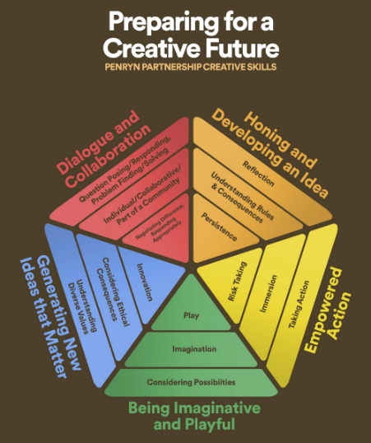


David Barton
CASH Executive Officer
07980719597
dbarton@cornwallsecondaryheads.co.uk

