BULLETIN INFORMATION FOR HEADTEACHERS

- The Cornwall Area SEND Inspection report has been published – see first link. The second link is the NHS press release following its publication with comment from Kate Evan-Hughes and Cllr Barbara Ellenbroek.  - I received an email from Fatma this morning thanking the dozen schools that have already completed the survey re sustainable food – thank you! I am also delighted that following contact with her from yourselves, she has arranged meetings with two schools and local farms already!  - At our CASH meeting I mentioned the announcement by the DfE of nine new attendance hubs across the country. Kate Richardson leads the attendance work across Cabot Learning Foundation, so I’m very pleased that CLF has been confirmed as the SW hub, since I’d already booked her and have already met with her! Kate will be leading our CASH conference at Lanhydrock on 29th September…  - ...I also reported back on attendance being the current focus and work of the Cornwall Education Partnership (CEP) hosted by Kate Evan-Hughes and chaired by Dan Buckley (CEO, SMART). I promised to include a short summary of who sits on CEP and the current attendance work being done at the moment. Here it is. CASH and CAPH are specifically included to ensure that SATs, Foundation Trust and maintained schools are represented.  - There is an article in Schools Week this morning that focusses on the current DfE approach to academisation as seen through the eyes of two RSCs including or region’s Hannah Woodhouse.  - The Cornwall Smokefree Alliance has reconvened post pandemic with an additional focus on vaping. Please see this letter giving an update following the first tranche of board meetings and workgroups (on which I am representing you).  - Cornish Stories of Survival is a project that has been ongoing over the last couple of years focussing on Cornish survivors of the Holocaust, and schemes of work have been developed by RE and History colleagues at Torpoint and Penryn respectively. Throughout its development I have been liaising regularly with your RE and History subject leaders, but as we move into the third year there is a broadening out of the curriculum areas that may potentially be keen to become involved. There is a second annual conference in July to which school leaders are invited, and please feel free to share as widely across your school as you wish – RE, History and Art subject leads have already received this information and I shall copy this item to English subject leads, too. Graeme Plunkett is building the programme into Curriculum Kernewek and PSHE subject leads will be introduced to the project at their summer workshops, hosted by Graeme and the effectiveness team.  - Refugee Week runs from 19th-23rd June. Further to last week’s bulletin information re the Big Assembly, here are details of Cornwall Council’s activities during the week. The link considers a range of activities, the INSERT an education specific event on the afternoon of 20th June. | 50215730 (ofsted.gov.uk)  Cornwall’s education and health leaders welcome findings of Ofsted and CQC inspection of SEND services - NHS Cornwall and Isles of Scilly (icb.nhs.uk)  The survey link is here: https://exeterssis.eu.qualtrics.com/jfe/form/SV_56CGHClOn1J5dfE  Or, if you prefer here is a barcode access to the survey:    School attendance: DfE names new hubs and expands mentoring (schoolsweek.co.uk)  Developed by Kate Evan-Hughes to succeed the Standards Board (that Craig Martin used to sit on and report back to CASH, led by Jane Black when she was Director) this group has representation from:  CACE (Dan Buckley, who is Chair; Jenny Blunden TPAT; Phil Banks NCLT)  Alternative Provision (Rob Gasson)  Special Education (Guy Chappell)  Teaching School (Chris Challis)  Diocese (Katie Fitzsimmons, although she is moving to Salisbury diocese shortly)  RDD Office (Sarah King, although she is moving to Bristol and the new Cornwall person has been named as Jade Poole)  CAPH (Rachel Heffer & Jonathan Sleep)  CASH (David Barton)  Independent Schools (Andy Johnson, Truro School)  LA (Kate Evan-Hughes and Jacqui Piper).  The single focus since the group’s inception during the summer of the last academic year is Attendance, and Simon Elliott in the CoreStats team has done some excellent work – soon to be shared across all schools, I hope - producing heatmaps and other graphical information to support school leaders in grappling with the challenges in improving attendance. The data is drawn from the DfE Attendance portal and drills right down to individual postcode level and providing data for every primary and secondary school across the county. It is an interactive tool that allows you to filter by a whole range of school/trust cohort characteristics.  Refugee Week – 19th – 25th June 2023
DISCUSSION POINTS & DEBATES OF THE DAY

- Some of you are in the process of reviewing your curriculum with an intention to increase opportunities for creativity and creative thinking. This article written by Bill Lucas was published by the Chartered College last week with some interesting thoughts and model templates.  - Penryn College are rapidly moving toward the end of Year 2 of a national Creative Collaborative project; details of work so far and the overarching aims and objectives of the project can be found on the school’s website Year 1 - Penryn College (penryn-college.cornwall.sch.uk)  On June 12th the college is hosting an end of Year 2 update (virtual) to which anyone is invited - there is a £10 charge (free to BERA members) and the event runs from 3.30-6.45pm. All sorts of subject areas can benefit as well as school leaders; I attended the webinar last year and it was excellent with ideas for whole school and trust leadership. | Leadership for creative thinking in schools: How current research and innovation is putting creativity back into schools in England : My College (chartered.college)  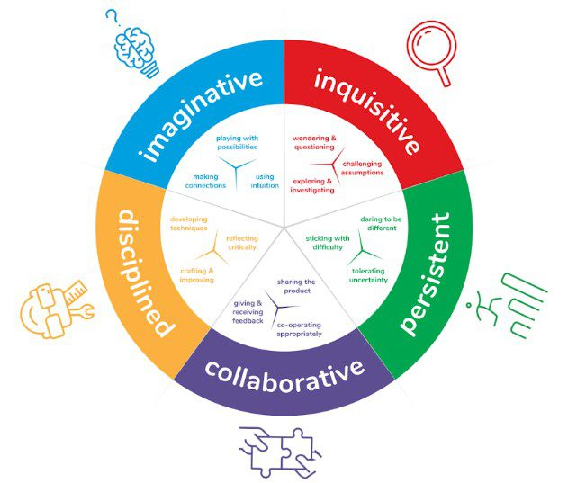  Booking and event information:  Creative pedagogies, research and practice in conversations | BERA
BULLETIN INFORMATION FOR HEAD’S PAs

ADVANCE NOTICE OF STAFF/GOVERNOR TRAINING, STUDENT AND OTHER EVENTS

These events are listed chronologically and
will only disappear once they have happened!

- The final one of the four LA curriculum roadshows take place this term at Heartlands, Redruth on 29th June. Details and booking on the INSERT.

- The LA are again running PSHE workshops this summer; feedback from last year’s sessions was very positive. There are four sessions in June, two in Bodmin and two in Truro, you only need to attend one! The workshops will include content on vaping and social media/influencers. Full details and booking on the INSERT.

- The rearranged dates of the six locality Onen Hag Oll meetings have now been confirmed. All of them are in the seven day period 12-19th June. See INSERTs – the Word document has the dates and venues, the pdf has been sent to schools – a letter from Kate Evan-Hughes re the Onen Hag Oll rationale.


David Barton
CASH Executive Officer
07980719597
dbarton@cornwallsecondaryheads.co.uk

