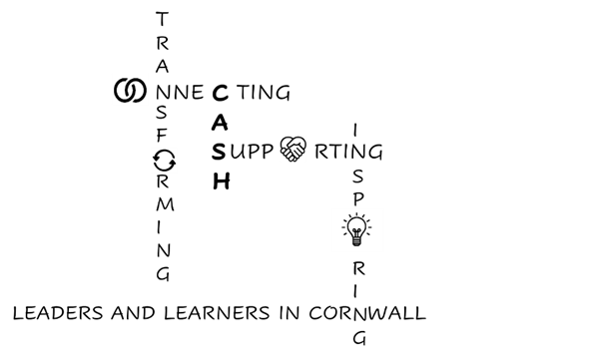

CASH Development Plan 2026 – 2027

Strategic aims, to:

Collaborate…generously across Cornish secondaries and with other partner organisations to ensure the Cornish voice is heard and to improve outcomes for all.


Align…with national and local priorities as identified by data and research evidence.


Support…all leaders and learners to flourish through effective information sharing, wellbeing support and high-quality professional learning opportunities.

Hone…expertise drawing on evidence-based research to provide a world class education for Cornwall.

Strategic Priorities | What do we want to achieve? | How will we do this? | How will we measure success? | Impact assessment  July 2027
Collaborate…generously across Cornish secondaries and with other partner organisations to ensure the Cornish voice is heard and to improve outcomes for all. | Improve outcomes for all Cornish children, in particular  - Reduce exclusions and suspensions  - Improve attendance and reduce NEETs  - Improve outcomes for SEND and disadvantaged learners | - Ensure CASH representation in a wide range of strategic decision-making groups  - Share expertise and best practice through a range of professional learning opportunities (bulletin, network meetings, conferences, Disciplined Inquiry projects) | - Impact of CASH representation on strategic groups and decision-making bodies  - Attendance at CASH conferences / network meetings  - Evaluations and feedback  - Cornish data metrics
Align…with national and local priorities as identified by data and research evidence. | Increase coherence, reduce duplication, and use resources more effectively, specifically with regard to:  - DfE, Cornwall, and LA priorities  - Changes to Ofsted and Accountability measures | - Ensure our conferences, network meetings and Disciplined Inquiries focus on local and national priorities and are shared across CASH for the good of all. | - Clear ‘golden threads’ run across the CASH calendar. Conferences/ network meetings have follow-up and evaluation of impact.

Support…all leaders and learners to flourish through effective information sharing, wellbeing support and high-quality professional learning opportunities | An impactful support offer for all CASH leaders to improve wellbeing, share workload and strengthen leadership across CASH schools. | - Ensure an effective Professional Learning offer for all CASH leaders  - Facilitate collaboration across schools and organisations  - Provide ‘buddying’ and pastoral support as appropriate | - Through leader feedback surveys
Hone…expertise drawing on evidence-based research to provide a world class education for Cornwall. | To support school leaders and teachers to provide the best possible educational experiences for our young people. | - Engage with research opportunities  - Share research findings effectively  - Support, where appropriate, the Disciplined Inquiries model and feed-back the work of CASH to other partners.  - Enable school leaders to engage with network and training opportunities | - Increase in cross-school/ cross-Trust collaboration  - ‘Directory of Expertise’ across CASH schools

