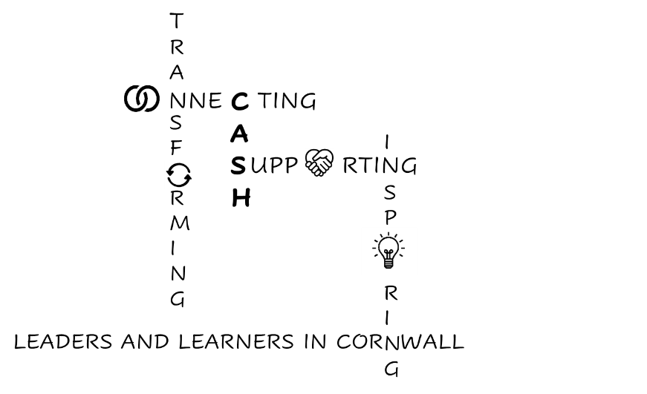
CASH Account
12.06.2026


Dear CASH Colleagues,

Please remember to respond to the Cornwall Education Partnership survey regarding the proposed education strategy for Cornwall.
Link to the survey is HERE - the closing date is 19 July.

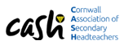
CASH AGM
A reminder that this will take place at the Conference on July 3rd. If you would like to raise an AOB, please contact Dom about this prior to the event: dom.wilkes@budehaven.cornwall.sch.uk
Agenda:
- CASH impact report and development plan
- Report from the Treasurer
- Election of Executive Committee for 2026-2028

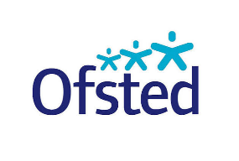
Simon Rowe presented at the CAPH Topical Thursday yesterday. A link to his presentation is here: Simon Rowe Ofsted presentation June 2026. I will provide detail at the conference, but I found this slide particularly interesting:
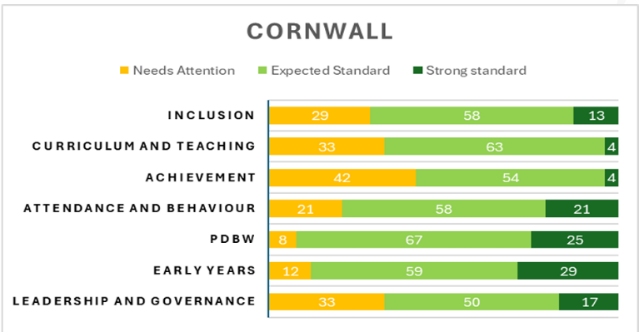
There is plenty of detail in his presentation around monitoring visits and the changes to the framework from September.
Schools Week commentary on the updated framework from September 2026 is here: Key changes to Ofsted from September 2026
Updated Schools Inspection Toolkit is here: Schools Inspection Toolkit from September 2026
Ofsted inspectors will look more closely at whether pupils with “barriers to their learning or wellbeing” are achieving well in schools from September.
The watchdog has also updated its guidance for inspectors to bring it in line with new requirements on allergy safety, inclusion bases and mobile phones.
There are quite a lot of significant changes so well worth a read.
We will be hearing from Jo Guest and Simon Horner (recently trained Inspectors) and from Paul Boyes (and hopefully Melissa Locke) who have both recently been inspected at the July 3rd Conference. Deborah Mitchell from Restorative Justice Working will also provide some input regarding the Inclusion standard.


The DfE has now published its Enrichment Benchmarks: DfE Schools Enrichment benchmarks June 2026. Although these are ‘non-statutory’ they will feed into the Ofsted PD judgment from September.
Schools Week commentary is here: What schools need to know about Enrichment benchmarks including a link to the self-assessment and action-planning tool.
The offer must align with school priorities including attainment, attendance, behaviour, careers guidance, curriculum, personal development and wellbeing.
It should be ‘multiple and varied’ covering at least:
- civic engagement
- arts and culture
- nature and the outdoors
- sport and physical activities
- life skills

And outcomes need to be tracked.


Linked to this, I’ve been contacted by Cognition Learning CiC who have secured over £200,000 to launch a major new initiative supporting 48 secondary schools and colleges across Devon and Cornwall to participate in the international FIRST Tech Challenge programme.

Each participating school will receive approximately £3,000 worth of funded support, including robotics equipment, staff and student training, links to a local industry mentor, competition events, and transport bursaries. The programme supports KS3 and KS4 learning, Gatsby Benchmarks, and essential skills development - with no previous STEM experience required.
The programme has been running internationally for over 20 years and in the UK since 2019. Our nearest existing programme is currently in Bournemouth, and we are keen to ensure that young people across Devon and Cornwall have access to the same opportunities. This also aligns closely with the government’s recent focus on enrichment benchmarks for schools.
You can book a meeting with Andy Robinson-Noades the director here: Book a call
Or his email address is andy@cogntionlearning.co.uk


Another change from September is that students from Year 7 must be taught about Suicide Prevention:
Resources can be accessed at www.papyrus-uk.org. I have shared these with your RSHE leads.
To access 24/7 fully qualified mental health HOPELINE support:
Text HOPE to: 88247
pat@papyrus-ukorg
Webchat: papyrus-uk.org.
Contrary to many helplines, Hopeline does intervene with each call. A suicide safety plan is
created.


The Fair Education Alliance has some interesting work around AI

Safe AI Experimentation with CAST

Back in March, our AI in Education peer working group took part in a workshop on responsible AI experimentation, led by CAST, a charity which supports organisations to use AI for social good. The session helped members build confidence without rushing to solutions or large-scale adoption. We explored what responsible experimentation looks like in practice, common risks and safeguards, and how to design small, ethical experiments that genuinely support your work.

Sound like something you’d like to explore? Here are three resources to get you going:
- Watch the recording and access the slide notes from the session.

- AI Experiments Library - CAST is building a library to help the sector learn from each other's real-world practice. If you've been piloting something, however small, browse examples and add your own here.

- Digital Leads Network - If you have a digital lead in your organisation, this free peer community is worth knowing about. Find out more and join here.


Deborah Mitchell from Restorative Justice Working has asked me to share this link with you. It is advice for schools regarding creating an inclusive culture in a society threatened by far-right ideologies. OpenEdge: Transforming Conflict. (As mentioned above, Deborah will input to our ‘Ofsted’ Conference Session with regards to the Inclusion standard.)

Linked to the above, Natalie is our link at Cornwall Council for any diversity incidents.
Natalie Parr (Natalie.parr@cornwall.gov.uk).
She can also provide:
- Support for refugee/resettled students including trauma informed practice training for staff and reviews of practice
- Training and guidance for supporting students with EAL including a full audit of EAL provision and language assessments for students (helping schools to meet the statutory guidance under the OFSTED framework and Teacher’s Standards).
- Hate incident support: log any equality and diversity incidents through the Services for Schools page (https://secure2.sla-online.co.uk/v3/Resources/Page/46848). She monitors all incidents that are reported and contacts schools to offer support and guidance.
- Equality, diversity and inclusion full school audits and training
- Cultural capability/humility and anti-racist practice training gand guidance (helping schools to meet the statutory duties under the new Working Together to Safeguard Children guidance).

Other LA updates:

Information for Education Providers to share with families and young people
- Chat Future Youth Text Service -(YP aged 11-19)- education, employment and training advice and opportunities.
- Chat Health advice for children and young people - Cornwall Council for parents and YP (0-19).
- SEND Updates for Parents, Carers and Young People - Cornwall Council- please encourage parent/carers to sign up to receive the termly newsletter
- Empowered Parenting Podcasts - Cornwall Council- range of Podcasts including an overview of SEND by the SEND System Navigators.
- Listen & Translate- every council webpage has this function to translate the page into a different language and/or audio.
- Kernow Education Advice Line - Cornwall Council- provide early advice, guidance and information for parents, carers and students with questions or concerns about education. We help families understand learning, education choices and how children are feeling - and support them to get the right help at the right time.
- ND Parent Workshops- ND Profiling Tool- What is it and how is it used to support you and your child? Information sessions for Parent Carers on Neurodiversity. Tickets, Multiple dates | Eventbrite

Home to School Travel Assistance - Cornwall Council- Parent Carers must apply for School Transport ASAP. As soon as a child’s EHCP has a named placement then an application should be made. If the request is not submitted by this date, then transport may not be in place by the start of term. Year 11 students should also be applying for Post-16 Travel Assistance - Cornwall Council where needed. Please support getting this message to parents/carers.
SEND Support Services Advice Lines- PMNAT, CST, SEMH & OT advice line now live. Educational Psychology Service advice line remains available. All advice line details can be found by typing ‘advice line’ into the search bar once logged into ‘services for schools’ Home | Global search | SLA Online
Support for Education Providers and Parent/Carers to support children and young people.
- Autism in Schools Team - Advice Line

- SEND System Navigators - Cornwall Council- 01872 324242- calls will be triaged by trained contact centre advisers. If caller would like to speak with a SSN then the contact centre will triage/take details so the SSN can return the call at a later time.

- Phase Transfer- Parents/ Carers of children with an EHCP waiting for a YR or Y7 placement to be named should have had an email this week from the Stat SEND team updating them of the current situation and the ongoing work. If they have not, then please ask them to contact a SEND System Navigator or email ehcreviews@cornwall.gov.uk

- Stat SEND and SENDCo Link Meetings- If your SENDCo has not had communication about a summer term link meeting then please email sarah.wheildon@cornwall.gov.uk


Wellbeing support for Headteachers from Headsup4HTs Headsup4HTs.
If you would like to join the community, please use this link
You can also benefit from a free month of the app HeadsUp4HTs GPT App using the code CAPH . (Shout-Out to CAPH for sharing this with us).


Wild Wonder and Wisdom CIC are teaming up with Beyond the Wave CIC to deliver a range Aquatic Safety Qualifications designed by Atlantic Crest and accredited by the Institute for Outdoor Learning. They are an updated and improved replacement for the previous National Water Safety Management Programme (RLSS) that used to be delivered by Cornwall Outdoors before they were dissolved by Cornwall Council.
They are suitable for educational professionals and instructors who take groups near to, or in water, and we have specific modules for pools, inland water and the sea depending on need.
https://wildwonderandwisdom.co.uk/2026/06/11/aquatic-safety-qualification/
This week is drowning awareness week; we are offering special introductory prices on this course which will take place in Mevagissey.
Level 1 / 2 (beach module) 13th July £95
Level 1-3 13th and 14th July £180

I’ve got a meeting today with Morgan Stevens regarding the roll-out of the MHSTs so I’ll be able to update you with the progress of this next week.

Next week is also our final CSFT (Cornwall Sixth Forms Together) network meeting of the year on Wednesday at Chy Trevail. Our focus is on the impact of the post-16 Education and Skills White Paper.

And finally, THANK YOU for releasing your SENDCos to attend the OAIP (Ordinarily Available Inclusive Practice) planning event. Twelve SENDCos attended and every ‘sector’ was represented: LA schools, stand-alone academies and all of the Trusts, so hoorah!

Don’t forget to sign up for the Secondary RISE conference in Exeter on 29th July: South West Secondary School Improvement Network - Summer Conference 2026 – Fill out form

Please check updated CASH conference list below.
Have a good weekend everyone.

Kate

School | Head | SENDCo
Bodmin | CELT INSET day
Brannel
Budehaven | Dom Wilkes
Callington | Wendy Ainsworth
Camborne | Emma Haase
Cardrew Court | Kerry Towers
Cape
Falmouth | Jo Guest
Five Islands
Fowey | Ben Eddy | Laura Davies
Hayle | Melissa Lock | Naomi Thomson
Helston | Alex Lingard | Jo Greet
Humphry-Davy | Bill Marshall | Sophie Stephens
Launceston | Matt Thompson
Liskeard |  | Wendy Birkbeck
Looe | Paul Boyes | Hayley Gardner
Mounts Bay | Simon Horner (Exec Head)
Mullion | Michelle Dunleavy
Newquay Tretherras
Penair | James Davidson
Pencalenick | Joe McGovern
Penrice | CELT INSET
Penryn | Claire Croxall | Emily Quinn & Ben Gillo
Poltair | CELT INSET | Jackie Laurie
Pool | Matt Thompson (Exec Head) | Emily Comey
Redruth | Joe Cable
Richard Lander | Clare Beech | Victoria Whitlock
Saltash | Sara Del Gaudio | Jordan Speare
Sir James Smith’s | Marc Cooper | Cameo Woudberg
St Ives | Andrew Oates | Rebecca Hickson
The Roseland | Vanessa Maule | Holly Filkins
Torpoint | Jeremy Plumb | Chloe Turner
Treviglas | James Rogers | Thomas Wilson
Virtual School | Sarah Hamshaw | Claire Atkins
Wadebridge | Steve Simmonds
Wave | Chris Denley

Kate

