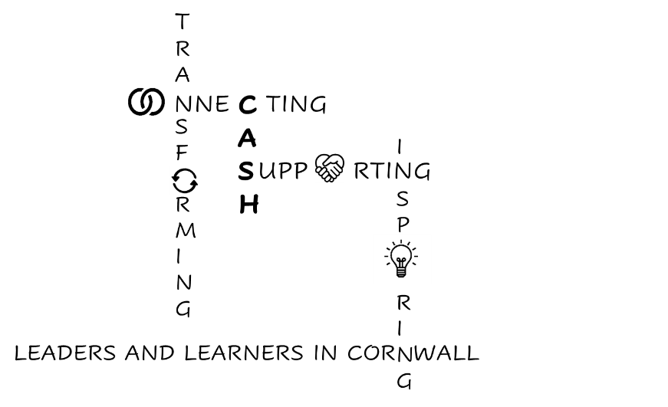
CASH Account
12.06.2026


Dear CASH Colleagues,


Cornwall Education Partnership are currently seeking views on the content for a new education strategy for Cornwall, which will set out how we seek to drive improvement in education provision to ensure that all children and young people have access to world-class opportunities and are able to achieve their potential.
To inform the strategy, we would like feedback from all stakeholders involved in education in Cornwall – including education professionals, families, and partner organisations – on your priorities and the strategic approaches we have included in the draft strategy.
Link to the survey is HERE - the closing date is 19 July.
Please do complete the questionnaire and circulate it to your staff to complete too. It is essential that the voices of those ‘on the ground’ are heard. I have completed it and it is a very thorough survey – well worth doing.
Contribute to post-16 SEND provision
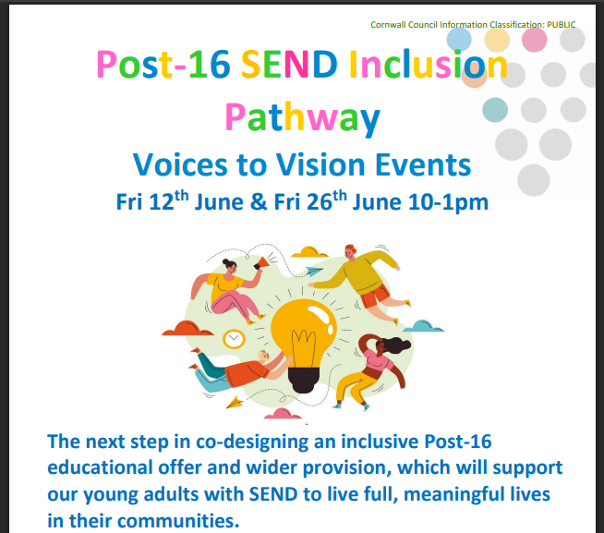
Who is invited:
• Parent/carers of young adults with SEND
• Post-16 Education & Supported Internship providers
• Cornwall Council Commissioners, SEND team and
Adult Education.

Come and:
• Hear what we have learned so far about improving Post16 opportunities for young people with SEND and what their “best life” looks like.
• Help us address the gaps and barriers in provision, and how we can align our different perspectives. • Co-design practical proposals, and next steps for the Inclusion Pathway work.
Friday 26th June 10-1pm. St Erme Community Centre, Trispen. TR4 9BD
Coffee from 9.30am. Contact Tffcommissioning@cornwall.gov.uk
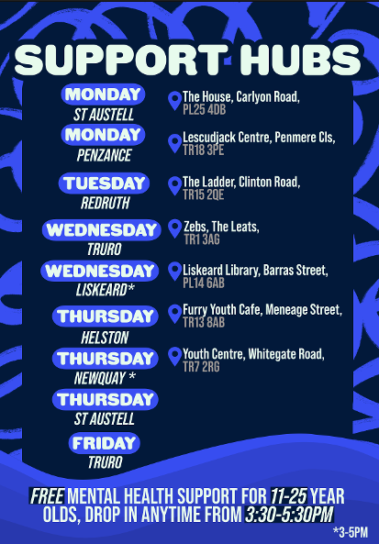
Please promote these Support Hubs for Young People.
Young people and their parents/carers/practitioners can drop-in for instant access to a wellbeing practitioner and youth worker.
No need for referral.


There is still a place left on the Leadership Skills Foundation’s Teacher-Leader of Creative Thinking Level 6 pilot programme. More detail on our website here: Professional Learning Opportunities


Cornwall Research School’s monthly digest is here: Cornwall Research School's June Digest


Thanks to Steve at Richard Lander for pointing out that the ASCL link I put in last week regarding the pay awards takes you to last year’s pages. I’ll share the 26-27 information when it’s available.


DfE News: Experts at Hand Guidance
The Government has published more information around its proposed Experts at Hand model: Experts at Hand teams. Here’s what Schools Week has to say: Schools Week Experts at Hand comment
Dr Jen Blunden, Chair of the Cornwall Operations Board, led us through this at the CAPH/CASH SENDCo conference yesterday and will be explaining our local approach at the CASH Conference on July 3rd.


CAPH/CASH SENDCo Conference (10.06.26)
The LA provided a brief update here: LA SEND update June 2026. There is some interesting information regarding funding available for schools if you are waiting for an EHC Needs Assessment: ‘Support Whilst Waiting with SEND’. I have also sent this to your SENDCos.
The main focus of the conference was on the creation of the Ordinarily Available Inclusive Practice Toolkit. There are further opportunities to be involved in each area:
Date & Time | Description | Teams link
25.6.26  2-3pm | External Services  Inclusive practice is strengthened through effective partnership working between schools, families and wider services. This area focuses on: multi-agency working; graduated response pathways; targeted and specialist support; early help approaches; Team Around the Child processes; accessing advice and guidance; and understanding referral pathways and thresholds. | External Services
02.7.26  2-3pm | Leadership  This area focuses on: inclusive vision and culture; strategic leadership of SEND and inclusion; staff development and confidence; accountability and quality assurance; co-production and partnership working; and creating sustainable inclusive practice. | Leadership

10.7.26  2-3pm | Environment  Inclusive environments help children and young people feel safe, regulated and ready to learn. This area focuses on: predictable routines and structures; sensory-aware environments; accessibility and reasonable adjustments; emotional and physical safety; calm and supportive spaces; and promoting independence and belonging. | Environment
14.7.26  2-3pm | Communication  Clear and consistent communication supports collaboration, partnership working and early identification of need. This area focuses on: communication with children and families; communication-friendly practice; accessible information; visual supports; collaborative working; graduated response documentation; and effective transition communication. | Communication
23.7.26  9-10am | Resources and Equipment  Some children and young people may require additional resources, adaptations or equipment to support access and independence. This area focuses on: assistive technology; adaptive resources; sensory supports; visual resources; accessibility tools; classroom adaptations; and effective use of specialist equipment. | Resources & Equipment
23.7.26  10-11am | EYFS  This is to review each section with a specific EYFS Lense. | EYFS
23.7.26  11-12noon | Post 16  This is to review each section with a specific Post 16 Lense. | Post 16
10.7.26  1-2pm | High Quality Teaching  High quality teaching is the foundation of inclusive practice and the first response to need. This area focuses on: adaptive teaching; scaffolding and modelling; responsive teaching approaches; reducing barriers to learning; assessment for learning; inclusive classroom routines; and maintaining high expectations for all learners. | High Quality Teaching

Updated conference list: please check for accuracy:
School | Head | SENDCo
Bodmin | CELT INSET day
Brannel
Budehaven | Dom Wilkes
Callington | Wendy Ainsworth
Camborne | Emma Haase
Cardrew Court | Kerry Towers
Cape
Falmouth | Jo Guest
Five Islands
Fowey | Ben Eddy | Laura Davies
Hayle | Melissa Lock | Naomi Thomson
Helston | Alex Lingard | Jo Greet
Humphry-Davy | Bill Marshall | Sophie Stephens
Launceston | Matt Thompson
Liskeard |  | Wendy Birkbeck
Looe | Paul Boyes | Hayley Gardner
Mounts Bay | Simon Horner
Mullion | Michelle Dunleavy
Newquay Tretherras
Penair | James Davidson
Pencalenick | Joe McGovern
Penrice
Penryn | Claire Croxall | Emily Quinn & Ben Gillo
Penrice |  | Jackie Laurie
Pool | Matt Thompson | Emily Comey
Redruth | Joe Cable | Katie Skilbeck
Richard Lander | Clare Beech | Victoria Whitlock
Saltash | Sara Del Gaudio | Jordan Speare
Sir James Smith’s | Marc Cooper | Cameo Woudberg
St Ives | Andrew Oates
The Roseland | Vanessa Maule | Holly Filkins
Torpoint | Jeremy Plumb | Chloe Turner
Treviglas | James Rogers | Thomas Wilson
Virtual School | Sarah Hamshaw | Claire Atkins
Wadebridge | Steve Simmonds
Wave | Chris Denley

Thank you so much for all you do.

Kate

