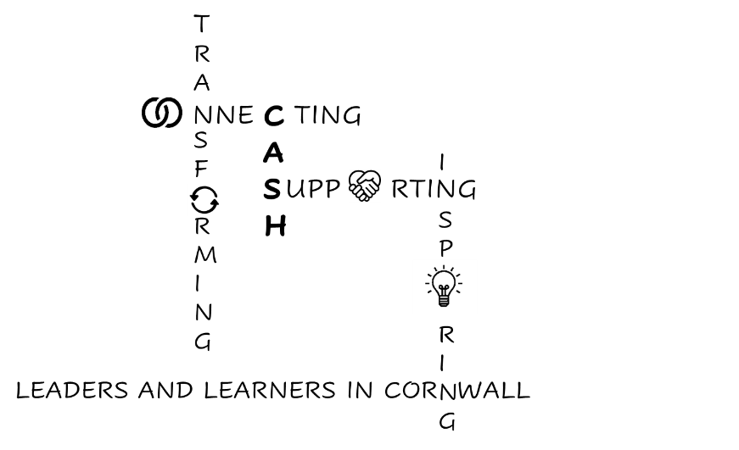
CASH Account
22.05.2026


Dear CASH Colleagues,
Happy Half Term! Well done: 5 down, 1 to go!

Summer Conference sign-up form is here: Sign up for CASH Summer Conference.
The agenda is here: CASH Summer Conference Agenda.
I have also invited your SENDCos to the morning (plus lunch) so it should be a really useful day.

Please indicate here: CASH Exec expression of interest form if you would like to stand as a member of CASH Executive. Please write your name (and go back and add it if you have just written ‘yes’!).

Meetings this week:

LA Maintained Schools Heads’ Meeting

Graeme shared this very helpful summary of the key White Paper milestones coming up next academic year: TES What's changing 2026-27. It’s organised month-by-month and there are a lot of changes coming in in September alone (I’ll leave you to read the article for the full year’s joy!).

September
- Phone ban and a cap on branded uniform
Now the Children’s Wellbeing and Schools Bill has received Royal Assent, new guidance on phones in schools becomes statutory from September, as does the cap on the number of branded items of school uniform (3).
Read more about what making phone guidance statutory will mean for schools here.

- Changes to safeguarding
The final version of the Keeping Children Safe In Education (KCSIE) 2026 guidance should come into force on 1 September.
The Department for Education is currently analysing feedback on its proposed changes to KCSIE 2025 to inform the final guidance.
You can read a full summary of the proposed changes here.

- New RSHE guidance
Teaching of new content for relationships, sex and health education will also begin in September, which includes things like more online safety and misogyny content. More details here.

- Introduction of enrichment benchmarks
Ofsted’s refresh of its inspection framework will also take effect from September - including inspecting the new enrichment benchmarks.

- Revisions to Progress 8
The government plans to publish its response to the key stage 4 accountability consultation in the summer term of 2026 so that schools can take into account revisions to Progress 8 from September, ahead of these being used in 2028.

- Allergy pens requirement
The government is consulting on new statutory requirements for schools to have to stock allergy pens and provide compulsory allergy awareness training for all staff.
These requirements are expected to come into force from September 2026 in the form of
Benedict’s Law (consultation open until mid-May) DfE: Benedict's Law.

It may be worth planning some training into your September INSET day, if not before. The law covers:
- Health Care Plans
- Training requirements
- Risk Assessments
- Emergency Response planning

There are changes to the way Section 19 applications are now managed: the application plus evidence needs to be sent to: section19@Cornwall.gov.uk
They are reviewed weekly by a panel, chaired by Nick Millward.
If the child is known to Social Care, Section 19 will not be granted.
The Policy is on the Services for Schools Platform: Cornwall Council Section 19 policy and procedure

Safeguarding: Please remind your staff to hide identifying information if they display student lists/seating plans on ClassCharts on the whiteboard. Remember in Cornwall we treat ‘Care Experienced’ as a Protected Characteristic.

Your feedback is sought regarding Locality Schools Meetings which are currently held across the six localities in Cornwall:
- Penwith
- Kerrier
- Carrick
- Restormel
- Caradon
- North Cornwall

These meetings are chaired by education colleagues and take place either termly or half-termly. The meeting chairs also come together once a term.
The current focus of the Locality Schools Meetings is on:
- Local issues affecting pupils, families and schools
- Service updates from wider stakeholders and partners, for example:
  - Police
  - Voluntary and community sector
  - Education Welfare
  - School Nursing
  - SEND services

Together, we are trying to better understand the effectiveness, strengths, challenges and opportunities of the current Locality Schools Meetings. This will include looking at other local network meetings and ensuring gaps and duplications are addressed.
To support this, we are inviting you to share your views through a short survey. All feedback will be reviewed, with the aim of developing a framework for future meetings. This will help to:
- Increase consistency across localities
- Retain local influence and flexibility
- Ensure local needs informs meeting focus

This work forms part of a wider programme to strengthen Early Support in Cornwall, particularly by building on existing practice and developing Locality Schools Meetings and broader Local Education Support Networks. This will help ensure all education settings have the information and resources they need.

Early Support is a proactive, multi-agency approach that identifies needs early and provides timely help, preventing challenges from escalating so that children, young people and families can thrive.

Help shape your future Locality Schools Meetings
By completing the survey, you will help inform how Locality Schools Meetings develop for the future. Please submit your responses by 5:00pm on Friday 22 May 2026.
Following the survey, any agreed changes to the Locality Schools Meetings will be implemented ahead of September 2026, in readiness for the 2026–27 academic year. Updates will be shared via the Schools Platform and by email.

Thank you for taking the time to contribute to this important work.

Education Colleagues - take the survey


South-West Attendance Network (SWAN) Meeting (RISE)

There was some interesting input from a range of Heads who have managed to improve attendance successfully. Top tips I particularly liked:

- Use the ‘View Your Education Data’ tool to download your Year 6 attendance dataset. It flags SA and PA as well as providing all the percentages. Use this to start conversations with primaries around strategies they have tried/what the issues are etc. Get in contact with these families and build supportive relationships early.
- Build an enhanced transition offer for students who are PA in Year 6 to help them ‘reset’ and build a sense of belonging with you.
- Send positive letters/postcards to children regarding outstanding, excellent and improving attendance (even if it’s just 1%) and the ‘legal’ letters to parents. Explain why you are using both approaches.
- You can register for SWAN updates here: Register for updates


SEND Board

The SEND Board meeting was really helpful in ensuring some joined-up working between SENDIASS, the LA and Parent-Carer Forum to try to ensure that consistent messaging is going to parents regarding attendance expectations (particularly with regards to anxiety). Future developments will involve parental groups run by the Mental Health Support Teams and some EBSA work run by the Local Authority.

The SEND Local Area Inspection Report will be published on Wednesday next week, so I’ll bring you the findings in the first Bulletin after half term.

The first draft of the SEND Reform Plan has been submitted to the DfE. I believe the ‘intent’ is strong and there are some really good plans in place to measure ‘impact’. I have asked for more opportunities for schools to be involved in what the ‘implementation’ might look like.

There was an update regarding the proposed 3 tier AP model. It is based on the work of the Alternative Provision Specialist Taskforce (with which Rob Gasson was involved).
Evaluation of the Alternative Provision Specialist Taskforce. Although there is not much quantitative evidence (because it wasn’t longitudinal) the qualitative feedback is strong. In essence the model is:
Tier 1: Using Experts at Hand to provide outreach support to schools.
Tier 2: Short term AP placements.
Tier 3: Longer term interventions for small cohorts leading to a move to another school.

Dates for your diaries:

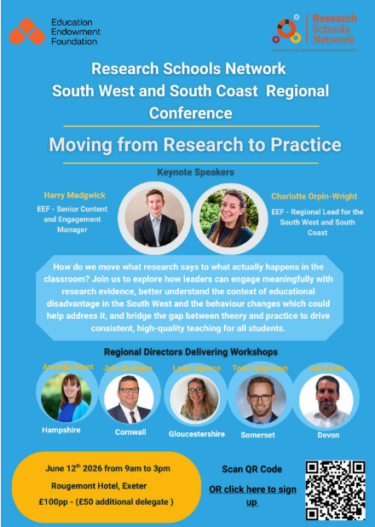
Don’t forget the Research School Conference on June 12th.

Exam Contingency day: Wednesday 24th June

With exam season now underway, the Joint Council for Qualifications (JCQ) is urging schools and colleges to remind students that Wednesday 24 June is reserved for the contingency day should any exams need to be rescheduled due to national or local emergencies. Students should be prepared to sit exams on that date if it is required.

Looking forward to 2026-2027

As you may remember, we are streamlining some professional development sessions across CAPH, CASH and CACE, under the CEP (Cornwall Education Partnership umbrella) next academic year to avoid duplication, share resources and ensure a joined-up message:

This week was the first joint Safeguarding conference. The slides are all hosted on the CAPH website here: CASH-CAPH-CACE Safeguarding meeting May 2026 (Password: CAPHhub2025). Thank you to all those who released DSLs to attend the event.

So, to next year:

CEP Leaders’ Conferences – for Heads
Weds 14th October 2026 – Eden Project
Tues 9th March 2027 – Wadebridge Showground

These will replace the CASH September and March conferences.

CASH Conferences:
Twilight Thurs 26th + all day Friday 27th November – Lanhydrock Hotel and Golf Club
Friday July 2nd – Lanhydrock Hotel and Golf Club
CEP Safeguarding Network – for DSLs
Tues 22 September 2026
Wed 3 February 2027
Thurs 20 May 2027

CEP SEND & Inclusion Network – for SENDCos
Wed 30 Sept 2026
Thurs 11 Feb 2027
Tues 22 June 2027

All are at Victoria Conference Centre, Roche, in person - 12.30 arrival, 1pm start and 3.30pm finish.



NPQ Update from OneCornwall/SWIFT

The following programmes will be fully funded and eligible to all publicly funded schools regardless of PP50 status: NPQH, NPQSENCO, NPQEYL (new), NPQSL (new)

The remaining NPQ programmes (LT,LTD, LBC, LPM, LL and EL) will continue to offer scholarship funding to participants from those schools/settings eligible under the PP50 data. The list of eligible schools is on the DfE website here

Please complete our expression of interest form as soon as possible so that we can communicate full application details at the earliest opportunity.

The application window will open on Tuesday 23 June 2026. Please direct any questions surrounding Autumn 2026 NPQs to fiona.mcneile@sw-ift.org.uk.


In the News

Here’s a shocker: who’d have predicted that?!

SchoolsWeek: Ofsted admit relationship between disadvantage and achievement judgement
Schools with above-average free school meals rates are almost three times as likely as those with below-average levels to be graded ‘needs attention’ or ‘urgent improvement’ for achievement.

Have a wonderful half term break. I hope you get time to relax in the sun.

Kate

