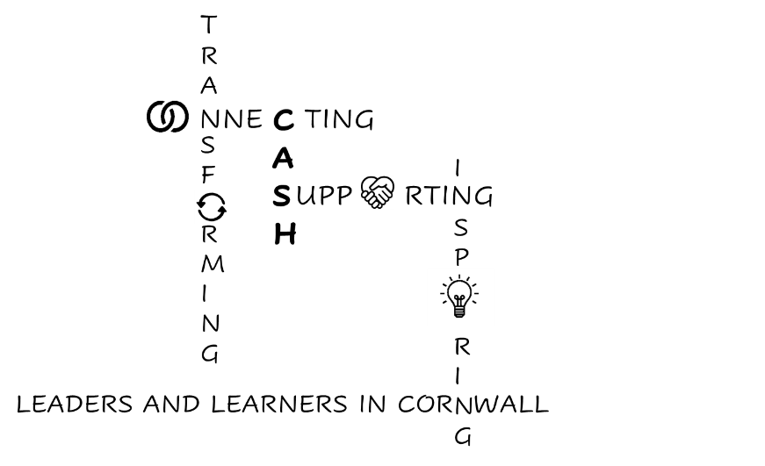
CASH Account
01.05.2026


Dear CASH Colleagues,

First of all, congratulations to Steve Simmonds who has been appointed Headteacher at Wadebridge School. We wish you well in your new role. Please do reach out if you need support with anything.


Well done, too to Humphry Davy School, who have completed some excellent parental engagement work. Humphry Davy Parental Engagement Case Study
Here is a message from Nicky Hepworth at Cornwall Council:
The Parental Engagement Framework is continuing to have an impact across the Duchy with over 70 schools working with the LA through their support package. This includes a number of Trusts, so the reach is over 100 schools. Schools produce a case study to demonstrate impact at the end of a 12–18-month period. Humphry Davy School have just completed their case study on parental engagement working with the Local Authority (see attached). As Kirsty Oliver, deputy head stated, “this work has strengthened consistency, refined communication and community practice, and ensured parental engagement is fully aligned with whole school priorities”.

The National Institute of Teaching is exploring how professional development works in schools, focusing on the DfE’s ‘Golden Thread’ of ITT, ECF, and NPQs.
To facilitate this, they’d be very grateful if you would consider completing their survey. Your insights will not only contribute to an original research study, but also directly shape the sector-wide guidance on professional development they will be producing as an output from the research.
It only takes 12-15 minutes to complete, and every input is valuable – helping them to ensure their work is grounded in real school practice and is useful for those working in schools and trusts.
NIoT research_Exploring school-level professional development in schools across England – Fill in f…
The survey will close by 23:45 on 30th June.


And on the subject of professional development, the University of Exeter is launching its Equity Leadership course: University of Exeter | Equity Leadership
The University of Exeter is one of the UK’s leading universities and is committed to creating a fairer world through its work in promoting evidence-informed policy and practice.
A member of the Russell Group and host of the South-West Social Mobility Commission, it brings unique expertise in tackling educational disadvantage.
Leading Educational Equity: From Principles to Practice
In a time of growing inequities inside and outside the school gates, school leaders are seeking new ways to improve outcomes for pupils from under-resourced backgrounds.
This new professional learning course is designed by the UK’s first Professor of Social Mobility, Lee Elliot Major OBE, alongside Anne-Marie Sim and Beth Brooks, co-authors of the Equity Scorecard.


The DfE has published changes to its Inclusive Mainstream Fund:
Inclusive mainstream fund for schools: methodology 2026 to 2027 - GOV.UK
The Inclusive Mainstream Fund for 2026/27 signals a clear national shift from accessing funding to demonstrating measurable impact. Schools will be expected to evidence strong inclusive provision, early identification of need, aligned leadership and systems, and improved engagement and attendance. The focus is no longer on intent or activity, but on outcomes.
This marks a move towards preventative, needs-led, whole-system approaches, with attendance as a key indicator of success. Schools that cannot demonstrate impact across inclusion, engagement, and attendance will not meet expectations.
Overall, this represents a system-wide shift towards scalable, long-term improvement in attendance, outcomes, and life chances.


Cornwall Council are seeking your views on their draft Belonging Strategy: https://letstalk.cornwall.gov.uk/belonging-in-cornwall
The deadline for feedback is May 6th. You can complete the survey by clicking the link above, or send your feedback to: equality@cornwall.gov.uk
I’ve downloaded the full document to our website here: Belonging in Cornwall Consultation document
Belonging in Cornwall – have your say – deadline 6 May 2026
Hi EDI Board External
Public consultation on Cornwall Council’s draft Belonging in Cornwall strategy closes on 6 May 2026. If you haven’t already fed back, there’s still time to complete the consultation survey or email us your feedback.
- For further information and the consultation survey, visit Belonging in Cornwall | Let's Talk Cornwall.
- Email feedback to equality@cornwall.gov.uk
What’s in the strategy?
The strategy is our commitment to equity, diversity, and inclusion over the next four years. It sets out plans for a fair and inclusive Cornwall where everyone feels welcome and that they belong. It helps us meet the requirements of the Equality Act 2010.
The strategy includes how we will work with organisations and communities. And how we will lead by example and promote our values of fairness, ambition, inclusion, and respect. It’s about improving how people access our buildings, services, and our information. It's also about making sure Cornwall Council is a fair and inclusive place to work.
Some of the things we will work on in the first year include:
- Carrying out accessibility audits on our buildings.
- Updating our reasonable adjustments policies.
- Looking at how we can increase our use of British Sign Language.
- Continuing our work on the Faith Covenant for Cornwall.
- Making sure we are following the Supreme Court ruling on the definition of sex in the Equality Act.
- Developing a toolkit to support trans colleagues and their managers.
- Looking at how we make our recruitment processes more inclusive.
- Sharing what we do with other organisations


You are invited to a ‘Bitesize Briefing’ with regards to Working Together to Safeguard Children 2026.

Working Together to Safeguard Children 2026 (WT2026) introduced important changes that strengthen how agencies work together to protect and promote the welfare of children.
Working together to safeguard children 2026: a guide to multi-agency working to help, protect and promote the welfare of children
WT2026 places greater emphasis on children’s lived experience, inclusion, confident information sharing, and understanding the wider social and economic factors that shape children and families’ lives.
Join us at the Bitesize Briefing 🧭 Understanding Working Together 2026 ‘Together across the Peninsula’ - for a clear, practical overview of what’s changed in Working Together 2026 and what it means for you in your role with a focus on:

👂 listening to children and families
🤝 shared responsibility and leadership
📤 confident information sharing
⚖️equity and inclusion
🎯 focusing on impact, not just process
This is a Free on-line briefing | For all partners and practitioners working or volunteering with children and families across the Peninsula
Delivered jointly by Partnership Managers across Cornwall & Isles of Scilly, Devon, Plymouth and Torbay
📅 Choose a date that suits you (one hour):
- Friday 22 May 2026 – 9.30am–10.30am
- Monday 1 June 2026 – 2.30pm–3.30pm
- Thursday 4 June 2026 – 4.30pm–5.30pm (Twilight session)
- Wednesday 10 June 2026 – 12.30pm–1.30pm (Lunchtime session)
📩Book via Microsoft Forms: Understanding Working Together 2026 'Together across the Peninsula' Bitesize Briefing – Fill in form


Meetings-wise this week, I’ve met with Elpida Achtaridou from Marjon University with regards to the research she is undertaking on behalf of the Local Authority around attendance. Thank you to you (or your attendance leads) if you have completed the transport survey I sent with last week’s bulletin and/or if you have sent out the links to the parent and student surveys for Elpida. Wow! We do have some challenges to overcome!


I’ve also met with Helen Arman from AQA and sent information about free subject leader courses at the University of Cambridge to your English, History, Maths, MFL and DT leads (the DT one is at York University). They are run by the King’s Institute (formerly PTI) and are fully funded weekend courses, with an overnight stay included. Of course, you will have to stump up for travel and accommodation for the Friday night, and possibly Sunday night, as our Cornish colleagues have so far to travel, but they are in July so the impact on cover will be minimised.


I’ve met with Margaret Mulholland from ASCL to discuss her keynote for our July Conference. (I’ll send the booking form after ½ term but make sure you keep 3rd July clear in your diaries if you can).

The Children and Young People Participation and Engagement event was interesting:


Look out for materials coming in to schools from CareFree Cornwall. They have been produced by children in care to raise awareness of their lived experiences.


Safer Futures has produced some really helpful resources Childs Voice and Domestic Abuse Toolkit especially around Coercive Control.
Results of the Right On survey will be out today.

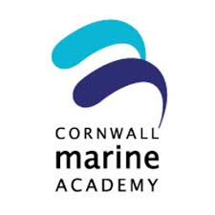
It was the Cornwall Marine Academy Board meeting this week, and I raised the issue of costs to schools for some of their really excellent initiatives (as well as the transport challenges!). They are working to secure funding from businesses to reduce the costs to schools.

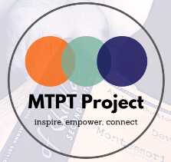
At Inclusive Education Communities we heard from the MTPT Project https://www.mtpt.org.uk/ (Maternity Teacher, Paternity Teacher). They offer free coaching and parental leave workshops to ease the transition back to work. The next parental leave group is on Tuesday 5th May and the next Return to Work workshop on 12th May. Please forward the information to your HR leads.
All our remaining Cradle to Classroom events are listed on Eventbrite:
🔗 https://www.eventbrite.co.uk/o/emma-sheppard-13216314101
Promotional materials for the South West are also available to download on our website:
🔗 https://www.mtpt.org.uk/cradle-to-classroom-fliers


The Ordinarily Available Provision workshop was a really positive event. The first draft of the plan will be shared at the CASH/CAPH/CACE Inclusion event on June 10th so please do release your SENDCo to attend. This is the ‘universal’ provision that will be an expectation for all pupils across all schools in Cornwall, so it’s really important that your voices are heard in its construction.

Enjoy the Bank Holiday weekend, everyone.

Kate

