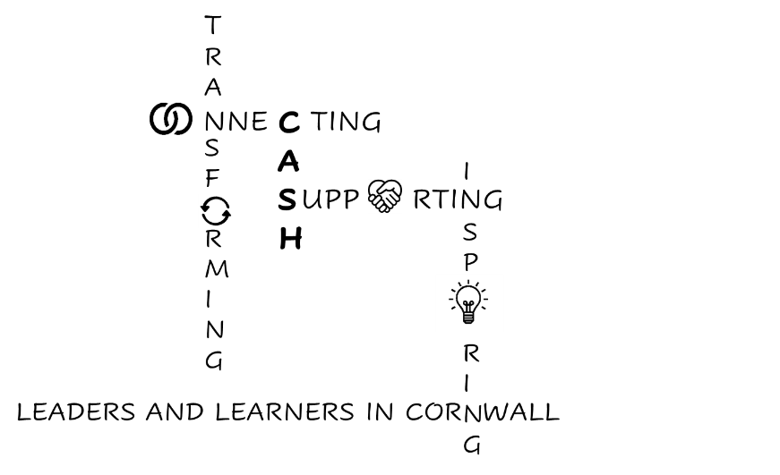
CASH Account
27.03.2026


Dear CASH Colleagues,
Well, it’s been an action-packed couple of weeks since the last bulletin.
Of course, the highlight was our Spring Conference last Friday!
Links to presentations here: Conference presentations Login: CASH. Password: EduKate
- Hayley Bissenden: CELT Centres of Excellence Professional Development opportunities
- Simon Rowe: Changes to Ofsted inspections
- Tom Middlehurst: Implications of policy change for school leaders
- Carrie Childs: Changes to the Careers Framework
- Jen Blunden: Inclusive Education Communities’ work
- Michelle Dunleavey: An example of a Disciplined Inquiry

Links to AQA consultation here:
Let's shape the future of assessment, together | AQA

Our Summer Term Conference is currently booked for Friday July 3rd but following Hayley’s presentation regarding the CELT Professional Development opportunities on that day, I wonder if we should try to rearrange (if the speakers I’ve booked are available on an alternative date.) Please complete this very short form by Thursday 2nd April, to indicate your availability on July 3rd and/or July 10th.
Summer Conference date selection
The focus of the Conference is the White Paper, especially changes to SEND provision. I’ve booked Margaret Mulholland, SEND and Inclusion Specialist from ASCL, to provide the national context and Rachel Delourme, Head of Inclusion and SEND at Cornwall Council, to provide the local context. We will have a SEND focus in the morning, and your SENDCos will be invited to join us.

In the afternoon, there will be input from Heads who’ve experienced Ofsted inspections under the new framework as well as those who have completed their Ofsted training. I will also slot in the AGM.

With regards to Ofsted, I’ve heard very varied feedback from those who have been through the new process. Some felt the process was very positive and accurate. I’ve heard the words, “collegiate, collaborative, kind and fair”. Whilst others, I know have fallen foul of the new ‘secure fit’ model, which has meant outcomes have been a limiting factor across several strands, forcing ‘Needs Attention’ gradings.

Bizarrely, I’ve also heard that HANDWRITING has been a focus in several inspections, so be prepared!

Here are the notes I took at the Conference:

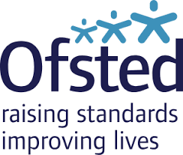
Simon Rowe, Ofsted
- Simon advised that he is happy to provide feedback on any documentation you’d like to check with him: simon.rowe@ofsted.gov.uk
- He reminded us that before the visit the team will have looked at your IDSR, any complaints they’ve received, the previous inspection report and the website
- The initial call is now on Teams
- There are 3 out-and-about points: student arrival, break, lunchtime
- The focus on Day 1 is Achievement, Curriculum & Teaching and Behaviour
- You will be asked to group subjects that are ‘strong’ and those that are ‘developing’ to facilitate learning walks
- The focus is to test the SEF (although there is no need for this to be written)
- Make sure your school information on GIAS (Get Information About Schools) is up-to-date as this is drawn down into your inspection report
- In the South West so far, 48% of gradings have been at least ‘Expected’.
- In terms of timeline. If your school is currently ‘Good’ or ungraded then you will be inspected 4 years from the report publication date.
- If your school was RI or declining, then the inspection will be 2.5 years from the date of your report publication date.
- If any area ‘needs attention’ then you will receive a monitoring inspection within 2 years, at which point the grading can be changed. (It can be moved up but not down).
- You get 5 working days’ notice before a monitoring inspection.
- If you are interested in the Peer Inspector training, then please complete the Expression of Interest form.

Expressions of interest for pilot programme
We have recently announced a new pilot for how we recruit and engage with new Ofsted inspectors.
If you are interested in forming a group and being involved in the pilot, please send an expression of interest to academy.oirecruitment@ofsted.gov.uk.
We are only accepting expressions of interest from schools and further education and skills providers at this stage.

- Tom Middlehurst advised Heads to have a nominee present during Ofsted inspections
- You should also advise the inspector during the initial call if you are neurodivergent, menopausal or perimenopausal.
- Check the Ofsted blog about mobile phone compliance How the DfE mobile phone guidance impacts inspections


Tom Middlehurst, ASCL

- There have been a lot of policy changes! (See powerpoint). Note that recruitment of exam invigilators will be impacted by the introduction of Day 1 rights from 2027.
- The Children and Wellbeing Schools Bill aligns academies and LA schools.
  - The new National Curriculum will apply to all schools from 2028
  - All teachers must have or be working towards teacher status
  - There will be a mobile phone ban, and a cap on uniform price
  - All 3 sciences must be offered at KS4 for our current Year 9 students
  - All students must be able to read music and play an instrument by the end of KS3
  - There is a large focus on KS3 (which will be 3 years) including diagnostic tests in English and Maths in Year 8 and the mandatory use of 3rd party providers to check reading proficiency
  - Digital, financial, media, oracy and climate science & sustainability strands are being introduced along with literacy and mathematics across all subjects
  - Representation and Diversity will be integrated
- The National Curriculum will be a digital product and will flag key concepts and learning. It will be fully resourced through Oak National Academy by Easter 2027 and will be mandatory for September 2028.
- There is no reduction in content or number of exams at GCSE, but a 10% reduction in length.
- Sadly, there is no focus on the accessibility of the curriculum, alongside the SEND reforms.
- ASCL are consulting on the L1 stepping-stone qualifications for post-16 students. There is an expectation that students will engage for 100 hours per year and this will be linked to funding.
- L2 occupational and foundational certificates will be introduced post-16 along with V levels that are replacing AGQs and AAQs.
- DfE data bandings are set to change to bottom quintile, middle and upper.
- Current Year 6 students will be the first to sit the new GCSEs. It is likely that there will no longer be formula sheets (think about the additional support your Maths and Science ECTs will need to teach without these).
- The Enrichment Entitlement is very demanding and includes:
  - Civic Engagement
  - Arts and Culture
  - Nature, Outdoor and Adventure
  - Sport and Physical
  - Developing Wider Life Skills

Please find the link to the DfE Performance Measures and RISE expansion consultation here: DfE consultation re KS4 performance measures

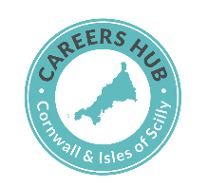
Carrie Childs, Careers Hub
Carrie explained the importance of the OnTrack+ tool

NEET Prevention - Introducing OnTrack+

OnTrack+ gives you a simple, data driven way to spot vulnerable learners earlier (Years 7–11), using indicators such as persistent absence, pupil premium, and known risk factors. It helps schools intervene before pupils hit crisis point, reducing the pressure on pastoral, SEND and attendance systems.
The tool will support you in NEET prevention and offer a more data driven approach to help students to achieve better outcomes, especially if they are from an under resourced background.

A Practical Solution - OnTrack+

Find out More

Please can you confirm within your school or Trust who would take a lead role for this work using the following template:

OnTrack+ Lead at Your Institution

After that, we can arrange a short 20-minute call to discuss everything in more detail with the assigned member/s of staff. I will provide a clearer breakdown of the differences between OnTrack+, Cornwall Council’s Your Futures Cornwall, and how each system aligns with your existing data.

- She also emphasised that Careers Leaders need to be senior, strategic and operational and be able to operate a network of employers
- There are now Learning Objectives that must be delivered through the Careers Curriculum
- You need to be able to evidence how career-ready your students are (use the career readiness framework)
- She also signposted us to the Cornwall and the Isles of Scilly Workforce and Skills Strategy
- Here are the Updated Gatsby Benchmarks


SENDCo Conference:

Thank you for releasing your SENDCos for the SENDCo conference on Tuesday. It was very positively evaluated. I won’t put all of the notes here as I will send to your SENDCos along with the powerpoints, but I will share a few highlights with you.
Looe and Pool shared their Ofsted experiences with us. Powerpoint here: SENDCo conference Ofsted and the White Paper
Top Tips:
- Present your school context
- Your SENDCo must know the Ofsted Toolkit really well
- Prepare summary sheets for staff
- Keep SEND top of the agenda:
  - Share SEND parent meeting notes with staff
  - Focus on adaptive teaching strategies weekly
  - Embed normal way of working from Year 7
  - Ensure your specialist teachers focus on the SEND students
  - Provide predictability through classroom routines
  - Annotate seating plans
  - Use drop-ins to ensure the SEND children are monitored effectively
- Ensure your reading ages are accurate. These will be triangulated with English books. Have a strategy for improving these.
- Be prepared to discuss handwriting and strategies for improving this. Mel at the LA can help with this: www.physicalandmedicalneeds@cornwall.gov.uk
- Provide Case Studies with clear Intent – Implementation – Impact to share with the team (in case the students they select don’t make you shine!)
- Case Study students will be SEND, In Care, PP, vulnerable
- ‘Groom’ your SEND parents so that Parent-View is positive
- Work with your curriculum leaders to ensure it’s clear how the curriculum is adapted to meet the needs of SEND learners
- Have a narrative around any books with less work. Pre-select books that show change happening
- ‘Built-in’ not ‘bold-on’
- Complete the Neurodiversity Profiling Tool for most dysregulated students to see if there is unmet need
- www.SEMH.org.uk very useful
- Focus on creating a culture of belonging.
- You have a SENDCo, not a SENDDo! Make sure you have a strong team around your SENDCo.
Finally, keep asking whether any additional evidence is required to secure an ‘expected judgment of better – they are open to this.

This report by the Office for National Statistics may be helpful in preparing your case studies.
ONS report: Impact of parental mental health on school outcomes

There is a lot in Schools Week about SEND at the moment:
New inclusion strategies: what schools need to know. This summarises what schools need to produce as part of their Inclusion Strategy and Universal Offer.
The DfE has said schools should produce an inclusion plan by December 31, 2026.
According to the new documents, schools’ strategies should set out how leaders will “ensure high quality ordinarily available provision which meet children’s needs” and fulfil conditions of the inclusive mainstream grant.
If you/your SENDCo has not yet signed up for the workshop on April 30th to discuss Ordinarily Available Provision, then please do:
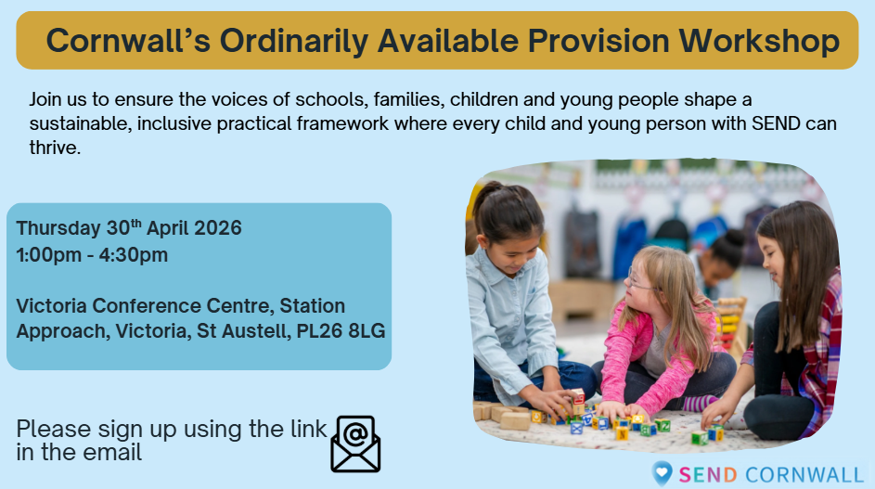
Cornwall’s Ordinarily Available Provision Workshop – Fill in form

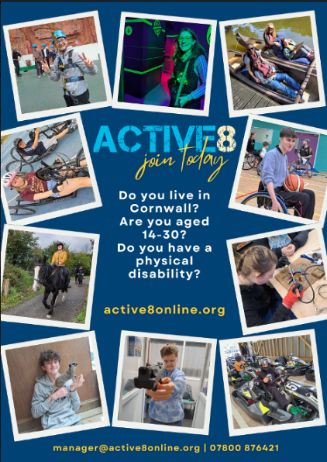
Active8 are looking for young people (aged 14-30) with a physical disability, to become a part of their new project group, take part in residential weekends away, try amazing new activities, and build confidence and independence along the way.
Referrals can be made by a professional, parent, or the young person themselves: Referral | Active8
Active8 is a Cornwall-based youth group supporting young people with any type of physical disability and no impactful learning disability. Our projects give young people fun new experiences... from screen printing, ceramics, zipwire, cooking, sailing, horse riding, GoKarting, Quad Biking... no two days at Active8 are the same and our projects are shaped around what our members want to do.
Activities are fully funded, accessible transport may be available, and activities take place outside term time so school/College are not impacted.
“Over the last couple of years, I’ve become more aware of what I like, what I want, and things that I want to be doing. I would say to give it a go – you’ll probably find that you’ll love it.” Stan, Active8 member, March 2026
Any questions? Please contact John or Lindsey our youth worker on yw@active8online.org


The Youth Justice Board (YJB) has published an Evidence and Insights Pack that brings together the national evidence on harmful sexual behaviour, misogyny, and violence carried out by children across England and Wales.
YJB Misogyny and Violence evidence pack
It is worth a read, as Ofsted now speak to students about misogyny and racism.

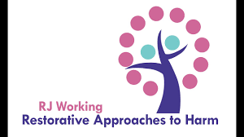
R J Working are offering online training regarding tackling racism restoratively:
Mon 30th March, 1.30 – 4.30pm, Online
This workshop will enable your staff team to develop a basic understanding of Restorative Practice and its relevance for racism, a harm to identity.
Participants will exchange learning as a group, to:
- Understand the impact of identity-based harm in Cornwall, especially racism
- Build knowledge, confidence and strategies to deal with racism when it arises
- Identify potential ways forward and activate confidence for change at personal, organisational and community levels

Tackling Racism Restoratively 1/2 Day - RJ Working
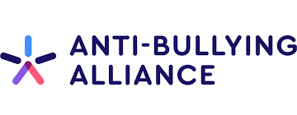
The Anti-Bullying Alliance has produced some resources regarding sexist and sexual bullying: Sexist and sexual bullying

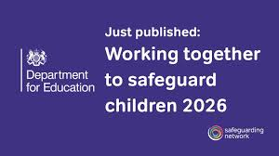
A summary of the changes to ‘Working Together to Safeguard Children’ is here: Working Together to Safeguard Children update


The Cornwall Research School Spring Newsletter is here: Research School Spring Newsletter
EEF Check. Adapt. Resource: EEF Adaptive Teaching new resource


Free online AI in Education training: On-demand AI training
The delivery is online, and the 4 modules cover:
Session 1 | AI, Education, and the Curriculum & Assessment Review examines AI in the context of the Curriculum and Assessment Review, exploring what the emerging direction of travel means for subject curricula, assessment models, and classroom practice.
Session 2 | Using Generative AI to Support Teaching and Learning moves into practical application, demonstrating how generative AI can enhance planning, explanation, retrieval practice, modelling, and feedback.
Session 3 | AI, Assessment, and Academic Integrity tackles one of the most pressing issues facing schools: assessment and academic integrity in an age of AI. You will explore practical, proportionate strategies to safeguard standards without retreating from innovation.
Session 4 | AI for Adaptive Teaching and Inclusion looks ahead, focusing on adaptive teaching and inclusion. You will consider how AI can support scaffolding, stretch, SEND provision, and workload reduction while keeping pedagogy at the centre.
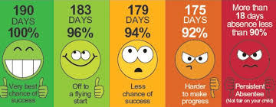
I would really appreciate your support with some Attendance research work that is being led by Elpida Achtaridou from Marjons University (who spoke at the Summer conference last year): Attendance research project. It is funded by the LA and feeds into the work led by the Attendance and Belonging working party that sits under CEP.
Please would you send these surveys to your parents/carers and students? It would really help us build a more robust response to the entrenched attendance issues we are facing. The associated ‘blurb’ is on the link above.
- parent/carer https://www.surveymonkey.com/r/96JLGR2
- student https://www.surveymonkey.com/r/96MNVPQ


School subjects influence political views
Research from Manchester, Bristol, and UCL reveals that school subjects influence political affiliations. Students who studied design and technology are more likely to support Reform, while those in music tend to favour the Green Party. The study tracked children from age ten, considering factors like household income and parental voting intentions. Researchers Nicole Martin, Ralph Scott, and Roland Kappe noted that arts students became liberal, while economics students remained right-wing. They clarified: "Recent governments have favoured increasing participation in science, tech, engineering and maths. Our study suggests this might in turn have consequences for young people's politics."
The Times


And finally, here is a thought-provoking article by Mohamed Abdallah (South West Regional Director at the Reach Foundation, referenced by Michelle at the Conference last week). https://www.reachfoundation.uk/)
To belong is not enough

It’s nearly Easter!
You’ve got this.

Kate

