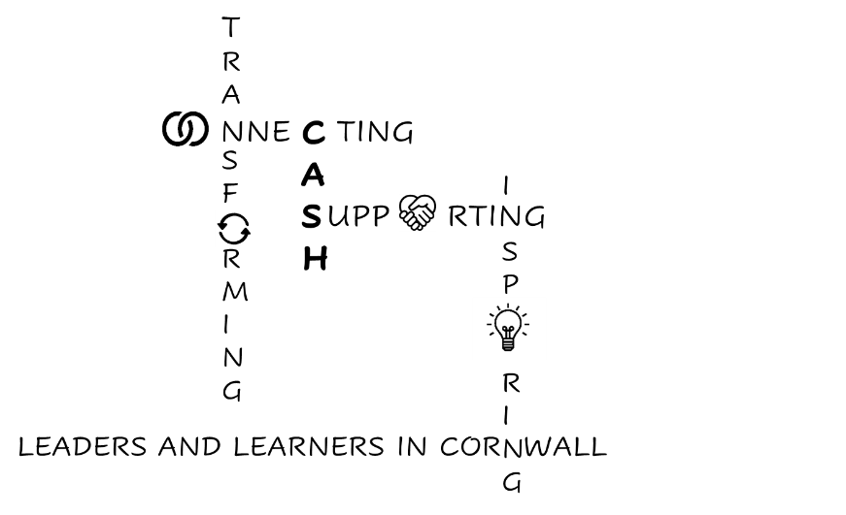
CASH Account
13.03.2026


Dear CASH Colleagues,
As you know, it’s the SEND Area Inspection for the Cornwall Local Area Partnership. Share your views here: Ofsted Area SEND inspection.
Remember, a lot of work is under way regarding improving SEND provision in Cornwall through the SEND Centres of Excellence work (latest report here: SEND Centres of Excellence Impact Report March 2026)
Alongside work on the Cornwall Inclusion Charter, there are two key Cornwall-wide workstreams: The Ordinarily Available Provision (OAIP) framework, and Neighbourhood Peer Panels, which focus on system-level improvements. Leaders are using these opportunities to share expertise, shape inclusive practice, and plan strategically for the year ahead.
There is still an opportunity to join these groups if you would like to contribute to the SEND conversation. Cornwall’s Ordinarily Available Provision Workshop – Fill in form (Invitation from Amy Daniels below):
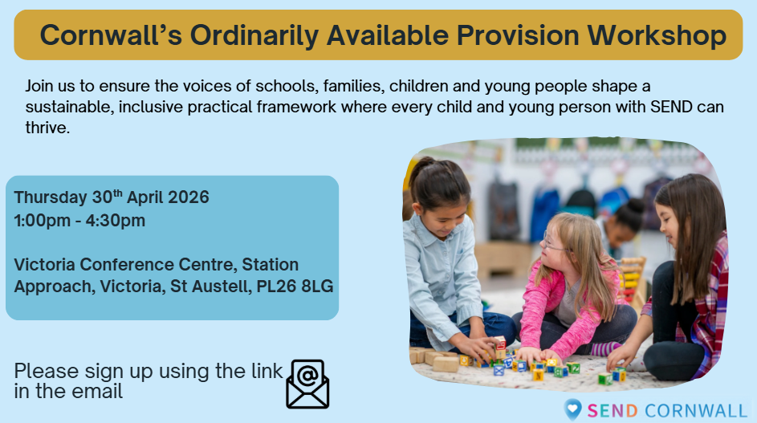
You are invited to help shape the future of inclusive education in Cornwall.
Cornwall is reviewing its Ordinarily Available Provision (OAP) to ensure that inclusion, wellbeing and high expectations are a consistent reality in mainstream education across the county.
This workshop will bring together early years, schools, colleges, families, children and young people, health and social care partners to co-produce a clear, practical and shared understanding of what should be ordinarily available for all children and young people.
Across the workshop, we will:
- Co-produce a clear, accessible framework that is designed for all learners
- Ensure the voices of children, young people and families shape the final guide
This is an opportunity to move from reactive, placement-driven responses to a system built on belonging, adaptability and equity, ensuring that the right support becomes part of everyday practice in every setting.
We warmly welcome education leaders, SENCOs, early years practitioners, post-16 providers, health and social care colleagues, parent/carer representatives, and the voices of children and young people to take part.
Together, we can build a shared, sustainable and inclusive approach that enables all children and young people with SEND to thrive in their local communities.
Join us and be part of shaping Cornwall’s Ordinarily Available Provision.

The slides from the Neighbourhood Peer Panels and meeting notes are available here: Neighbourhood Peer Panels: The Gloucester model. It seems to me to be a wonderful opportunity to direct resources locally. In Gloucester, the cluster approach involves:
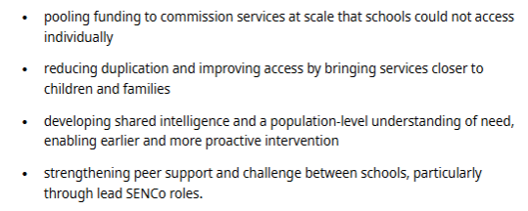
I will share more information as we create the model for Cornwall. If you are interested in joining this workstream then please contact Rachel Delourme: Rachel.delourme@cornwall.gov.uk


At the Cornwall Education Partnership meeting


Helen Salmon from Cornwall Council (Helen.Salmon@cornwall.gov.uk) presented an update regarding Early Support, including information regarding the development of Family Hubs. These will include a digital and pop-up offer for rural areas.

OneCornwall updated that they are working more closely with SWIFT and the National Institute of Teaching (I have the Advisory Group meeting next week so will know more then).
Chris Challis also updated regarding the Cornwall Ofsted training.
OneCornwall is well under way with the County's Ofsted Inspector Training Programme, in collaboration with our SW Regional Ofsted lead, Simon Rowe SHMI. The colleagues selected to be on the current programme had already expressed an interest in being a 'School Inspector' via the Ofsted portal: Ofsted inspector | Register your interest. For colleagues who are interested in developing their expertise in this area, it may be of use to review the pre-requisites for application, find out more information about the role and 'express an interest' using the link. Whilst nothing is confirmed yet, it would be a possible route into locality training in the future.
Having completed his training, Chris said that a key takeaway was the importance of the accuracy of the SEF particularly with regards to the Leadership and Management section.


Rob Gasson updated regarding Wave.
The Secondary provision is currently full, with a waiting list.


We met Fola Ariyibi from The Regions Group
The RISE Digital Skills and AI Hub conference is on 30th March 9-1 at Exeter Rugby Club.

Book here: Events - Digital Skills & AI Hub
If you are considering joining the Hub, this conference is an ideal opportunity to see the work in action, understand the standard of implementation expected, and connect with leaders already embedding AI strategically across their schools.
Intro from Jonathan Bishop OBE about the RISE project
Keynote from Laura Knight
Input on the AI Quality Mark from Daniel Emmerson of Good Future Foundation
Working Party Methodology - 'Test & Learn' model from Alex More
Networking and Lunch. Plus a chance to meet the RISE Steering Committee, working party leads and discuss membership.
There will also be 3 x 30-minute presentations from the 9 Working Parties:
- Leadership & Governance
- Business Efficiencies
- Reducing Workload
- Curriculum Content
- Student Practice, Attainment & Attendance
- Assessment, Marking & Feedback
- SEND & Adaptive Teaching
- Data Analytics
- Early Years & Oracy

To book a seat at the conference for free, click here.
To enquire about joining the Hub. - Visit the website digitalskills. education and click on 'Get Involved'


Graeme Plunkett presented a vision for the Local Authority to deliver the Universal RISE offer. I will share more information as it becomes available.


We had a good Cornwall Sixth Forms Together meeting yesterday.

Pearson presented really well regarding all of the curriculum changes that are coming post-16. I have sent the resources to your Heads of Sixth, but they are also here for your convenience: Post-16 changes Pearson presentation
Also in the news, Sixth Forms are facing funding cuts: Sixth Form Funding cuts
BTEC defunding is delayed: BTEC defunding delayed
The DfE has published a ‘technical note’ which shows that schools will have only enough financial ‘headroom’ to afford a pay increase of 2.7% over the next two years. The DfE has proposed a 6.5% pay award over three years and we are currently awaiting the verdict of the pay review body.
The DfE technical note says that “it is clear from our analysis that schools will need to realise and sustain better value from existing spending … to support the creation of additional headroom to improve the manageability of a 6.5% pay increase over the three years.”

The DfE is consulting on proposed updates to the statutory guidance, ‘Supporting pupils with medical conditions at school.’ The consultation closes on Friday 1 May, ahead of the proposals coming into force in September.
As part of this guidance there are new measures to safeguard children with allergies, which includes requiring schools and colleges to stock allergy pens, provide training for all staff, and have a dedicated allergy policy. More here


Also, this week, The Careers Hub has shared their OnTrack+ tool: OnTrack+ to try to identify children at risk of NEET. OnTrack+ gives you a simple, data driven way to spot vulnerable learners earlier (Years 7–11), using indicators such as persistent absence, pupil premium, and known risk factors. It helps schools intervene before pupils hit crisis point, reducing the pressure on pastoral, SEND and attendance systems. Carrie will be at our conference next Friday and so will be able to answer any questions you may have.

In other news:

The Parent-Carer Forum has asked me to share details of their Youtube channel and Facebook page with you to share with your parent-carer networks.
What is Parent-Carer Forum Youtube
Parent-Carer Forum Facebook


I have shared information with regards to the English Hub Reading Showcase events at Penrice with your English Leads. There is evidence that the English Hub work is having substantial impact: English Hubs impact and the roll-out into Secondaries is now beginning.



Reading showcase booking form

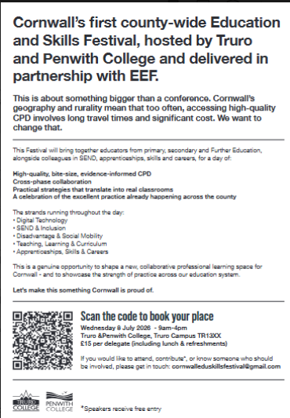
And another plug for:


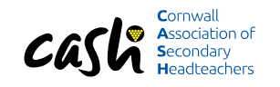
Of course, the most important reminder is that it is our Conference next Friday: 8.45 – 3.30 (coffee from 8.15am) at Lanhydrock Hotel and Gold Club. I am very excited that 28 schools (and all Trusts) will be represented this time. If for any reason you are no longer able to attend, please do let me know in advance if you can so that we are not charged for extra lunches!
From 8.15 | Coffee in the bar and a chance to chat to Deborah Mitchell from Restorative Justice Working about ways to improve students’ sense of belonging. | 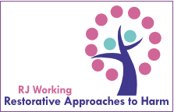  RJ Working
8.50 | Welcome and outline of the day | 
9am | Simon Rowe, Senior HMI from Ofsted talking us through changes to the Inspection Framework and sharing insights from the first wave of inspections. | 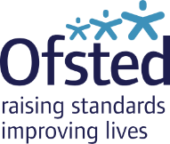  Ofsted pen portraits
10am | Tom Middlehurst, Deputy Director of Policy from ASCL on the Curriculum and Assessment Review and implications for school leaders (and a few bits about the White Paper!). |   ASCL: people
11am | Coffee and pastries and an opportunity to chat to Helen Arman from AQA regarding AQA support for the Curriculum and Assessment changes. |   AQA Account Managers
11.30 | Carrie Childs from the Cornwall Careers Hub and a speaker from the Careers and Enterprise Company, around the changes in Careers Education. | 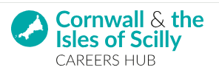  Cornwall Careers Hub
12.30 | Dr Jen Blunden, OBE, CEO of TPAT and Chair of the Cornwall Operations Board regarding using Disciplined Inquiry as a tool for change. |   Profile of Jen Blunden, Schools Week
1pm | Lunch and an opportunity to chat Matthew James from Step-Into-Teaching around ways to use graduates to fill skills-gaps in your schools. | 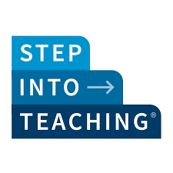  Step Into Teaching
1.45 | Nia Richards, Director of Creativity, Culture and Education, and Sarah Childs lead for the Penryn Creativity Collaboratives will help us find our way through all of these changes whilst remaining sane. |   CCE  Penryn Creativity Collaboratives
3.15 | Final thoughts | 
3.30 | Conference closes

Looking forward to seeing you on Friday.
Kate

