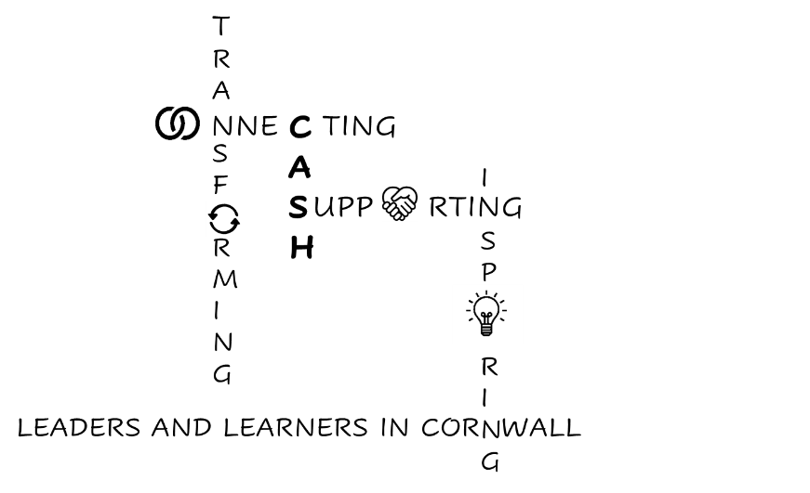
CASH Account
05.03.2026


Dear CASH Colleagues,
Meetings this week:

ASCL White Paper Briefing: “There are more questions than answers”.
Recording of webinar and resources here: ASCL White Paper resources

SEND – Margaret Mulholland
- Secondary schools will receive 160 days specialist access (Experts at Hand).
- ASCL anticipates that 1/8 children will move from EHCPs to ISPs (from 2029 at the point of transition).
- Specialist Bases will be commissioned by the LA.
Funding & Structure – Julia Harnden
- The Inclusion Mainstream Fund will go direct to schools (not via LA, unless LA school).
- It is an “expectation” not a “compulsion” for all schools to be in Trusts.
- Trusts must be civic institutions (hence share their ‘experts’ in SEND – see above).
‘Frameworks’ – Tom Middlehurst
- The ‘Enrichment’ framework will be assessed like Gatsby with benchmarks. From September 2026 Ofsted will report on this as part of the PD judgement. There is no additional funding for schools, although other organisations are receiving investment, so schools need to work with other organisations to meet the benchmarks.
- Pupil Engagement – questions will be provided to use with pupils around belonging, inclusion and engagement. Schools must be using these by September 2029.
- Home-School partnerships – there will be minimum expectations
- There will also be minimum expectations around:
  - Digital complaints (Schools Week thoughts here: Schools Week Complaint Reforms
  - School Profile
  - Attendance (with AI generated targets and RISE Hubs support)
The KS4 Accountability and RISE Consultation closes at the end of May.
DfE Accountability and RISE consultation
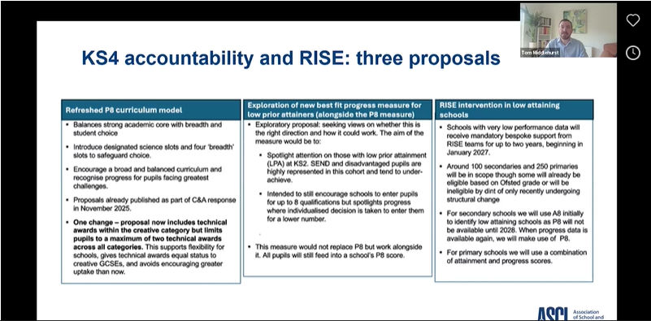
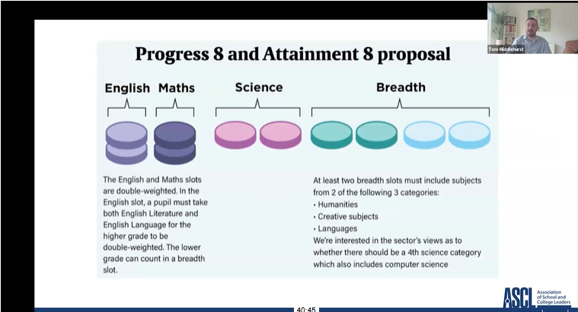

There are suggested changes to A8 and P8.
I like the proposal around the new progress measure for LPAs. The minimum expectation is Eng + Maths + 1 other. (P3). Schools can choose whether LPA students are entered for P3, P4, P5, P6, P7 or P8. Their best score will be used in the school’s measure. (This will be in place for the current Year 8 cohort if the changes are brought in).
From January 2027 RISE intervention will be triggered by A8 data as well as Ofsted.
The new National Curriculum is due to be published in September. ASCL expects a 3 year KS3 to be mandatory from 2028.


CAPH Board Meeting

Wolferstans provided some employment law updates.
- Changes to the Qualifying Service for Unfair Dismissal. You can currently dismiss within the first two years without legal recourse (who knew?!). This is changing to 6 months from 1st January 2027. Wolferstan’s advice is to have anyone employed by 1st July 2026 to have a 3 month probationary period which is tightly monitored allowing a 1 month extension and still allowing dismissal within 6 months.

- Fire and Re-Hire changes are coming in next year. Schools in Trusts need to ensure that their policies align across the Trust.

- Zero hours contracts. A ‘Guaranteed Hours Contract’ is being introduced which means after 12 weeks you must offer a permanent contract for the average number of hours worked across the 12 week period (this doesn’t have to be concurrent; it’s a rolling duty). Their advice is to use agency staff because then the agency has to pick up this responsibility.

- From April 1st paternity pay must be paid from day 1 of employment.

Wolferstans are presenting a CAPH webinar on the legalities around AI in education on March 25th. Wolferstans AI in education

Cat Scutt advised that the CEP Education Strategy will soon be ready for sharing. There is a CEP (Cornwall Education Partnership) meeting next Tuesday, so I should be able to update you after that.

Eveleen Riordan advised that the LA are open to a conversation around an LA Trust. Please contact her if you are interested.
She also explained that the LA budget is under significant pressure. The LA has to find £59 million in savings in 2026-27.
The LA had a Peer Challenge event and is making some good progress, but more systems work is needed.


SEND Board

Medical Needs in Schools – a lot of work has gone into a Task and Finish group including the LA, the ICB, NHS and schools. A clear outline of who does what will soon be available to share.

Parent-Carer Forum – please remind your parents that this exists! https://www.cornwallparentcarerforum.co.uk/
They can often provide support and guidance to relieve some of the burden on school staff and can be contacted at info@cornwallparentcarerforum.co.uk

PEX
- We have the 6th highest exclusions rate in the country. Last year 180 students were PEXed. Mostly SEND (SEMH) boys: 49 (yr9), 38 (yr 10), 34 (yr 8), 10 (yr 7), 9 (yr 11). The rest were Primary.
- The numbers have come down from the previous year (155 secondary 2023-24, 140 2024-25).
- Rob Gasson warned that Wave are losing 22 places in September.
- There was a discussion around whether PEX was too easy in Cornwall…
EHE
- 2728 children are registered as EHE. A high proportion are SEND with mental health cited by parents as the most common reason. (Plus there are currently 2000 children waiting for a neurodiversity assessment).

The good news is that the next Mental Health Support Teams are rolling out in Kerrier and Launceston/Bude in September. Jim (from Budehaven) presented a compelling case for this area to get some support in a meeting I attended with him a while ago, so well done Jim!
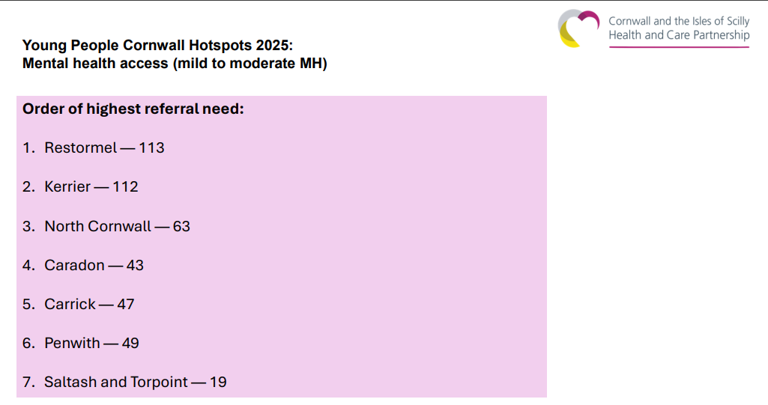
See below for map of NHS Neighbourhoods.
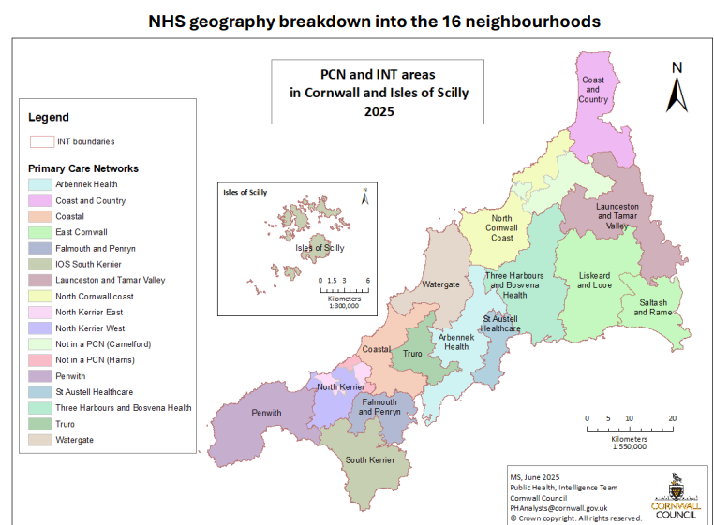

We were reminded to signpost parents to the Waiting Well programme Healthy Cornwall Waiting Well if they are waiting for any kind of assessment for their child.

A HUGE slide deck was shared that does show that the quality of EHCPs has improved and SEND attendance is improving; so well done for all the work you and your teams are putting into this.
There was also quite a scary slide about EHCP trajectories:
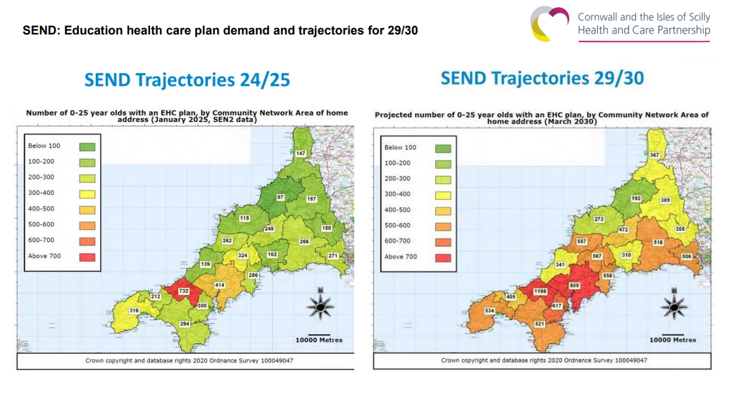

The Celebrating Neurodiversity Strategy from the Neurodiversity Steering Group is on our website here: Celebrating Neurodiversity Strategy update

In other news:


Cornwall Council would like to hear views:

Regarding 3 areas of the SEND SEF:
Identification and Assessment of Needs
- children and young people are accurately identified as having SEND
- children and young people’s needs are identified in a timely way, to prevent needs from escalating, whenever possible
- practitioners assess the strengths and determine the aspirations of the child or young person alongside their individual needs
- the criteria for carrying out assessments of need and for accessing services and support are understood, and the application of these criteria improves outcomes
- timely referrals are made to other services and agencies, where necessary

- Preparation for Next Steps and Outcomes
- the outcomes that are the most important to children, young people and their families are understood and planned for
- support and plans reflect children and young people’s ambitions, and extend beyond required levels of support (such as the number of hours of support from a particular service) to focus on the planned outcome
- children and young people are supported before and during any point of transition, including when they will no longer be eligible for a service
- from an early age, children and young people develop the knowledge, skills and behaviours necessary to prepare for greater independence and adulthood, including in the areas of further and higher education, employment, more independent living, optimal health, positive relationships and participation in society

- Leadership Ambition and Strategic Direction
Leaders set ambitious strategies and foster a culture of high expectations for supporting children and young people with SEND. They understand their responsibilities, ensure decision-making processes are efficient, and jointly evaluate the effectiveness of services and provision. Leaders monitor sufficiency and take action to address gaps, using diverse information sources, including feedback and outcome data, to drive improvements. Clear evaluation processes are established for ongoing service enhancement, with the local authority maintaining oversight and safety of alternative provision. Systems support timely collaboration and information sharing among practitioners, with a focus on identifying solutions that meet individual needs and ensuring practitioners possess the necessary knowledge and skills.
You are invited to attend a Teams meeting on 17th March 9am-1pm or please pass comments to me.
https://teams.microsoft.com/meet/39276550203104?p=EniImr6Jltqi7RymzN


Your views regarding the Parent Engagement Framework:
The single biggest opportunity to improve parental engagement is to plan effectively for it as part of a whole school approach. This means understanding the current context and having a shared vision for parental engagement across a school that everyone can work towards. With appropriate school-wide training and a strategic plan for parental engagement, activities are more outcome focused and impactful. (Dempster, Hepworth, Robbins 2024 ).
Cornwall Council’s Parental Engagement Framework (PEF) is having an impact across schools in the Duchy both as a free resource to education settings and for those schools that sign up to the support package. The quality of the Framework has been recognised by the DfE who have drawn on this work to inform the white paper to be published later this year on parental engagement. Please can all education settings complete this short survey which has been designed to determine the extent to which the PEF is being used as a free resource and its impact. For those schools on the support package, please do not complete this survey as you will be sent a link to a separate survey. This survey is live from 2nd to 20th March. Parent Engagement Survey

The LA has commissioned Plymouth University to undertake some research around attendance and would like your parents and students to participate in an attendance research project. More details here: Plymouth University Attendance research project


Cornwall Research School now has a really professional and accessible Research Digest: Cornwall Research School Research Digest


The EEF are now recruiting for four new secondary projects: EEF project recruitment. I thought the one around KS4 students’ mental health may be of interest.

And on that note:

The University of Exeter is looking to speak to teachers and school leaders about how you might use resources to create mental health policies in your school.
As part of the 4S Study, we have developed some guiding principles that schools can use to create or select policies to prevent and respond to suicide and self-harm. We would like to get some insight from you about how we can make those guiding principles easy to digest and use. Involvement will involve a short conversation either in-person at your school or online via Microsoft Teams. To thank you for your time, you will receive a £20 Love2Shop voucher.
If you or members of your staff would be interested in contributing your insights, we would be delighted to hear from you. Please email r.davis6@exeter.ac.uk with some days and times that would work for you to have a chat, or if you have any questions.


I think a potential solution for some students is this online platform because you can purchase it per lesson (£15).
Online provision for
- Students experiencing EBSNA or attendance difficulties
- Pupils at risk of PEX or during suspension periods
- Children looked after (CLA) requiring continuity of learning
- SEND learners who benefit from smaller online groups
- Internal inclusion and AP needs

Tute Education is a DfE accredited provider of live online lessons delivered by qualified teachers. Our live lessons have been arranged into a choice of curriculums that respond to different needs students have and different priorities schools have for them throughout the year.
Tute is designed to be flexible and cost-effective for schools. Schools only commission the lessons and curriculums they need for the students they wish to support, and provision can be adjusted or stopped as needs change. There are no fixed packages or long-term commitments, allowing schools to use the provision in a targeted way. Our most frequently commissioned Virtual School curriculum costs just £15.00 per student, per lesson.
You can see what a Tute lesson looks like by clicking here to watch a compilation of Tute lesson playbacks
Key features of the provision include:
- Live lessons taught by qualified teachers
- Small group learning environments
- Routes to achieving qualifications at functional skills and GCSE level
- Real-time attendance tracking and progress reporting
- Provision that can begin within 24-48hrs

Book a meeting with Kate McCombe to find out more:
If it would be helpful to explore whether Tute could support your setting, you are welcome to click here to access my calendar and book a Teams meeting directly or alternatively contact me with availability and I’ll schedule a meeting in for us.


Finally, can you let me know if you are having trouble with AI generated videos of staff on TikTok and if so, what you’ve done about it?


Please also let me know if you get the Ofsted call. I know that Looe and Pool have been inspected in the last couple of weeks. (Are they going for schools with double ‘oo’ or the ‘ooh’ sound?) If so, then Redruth watch out!

Have a good weekend everyone!


Kate

