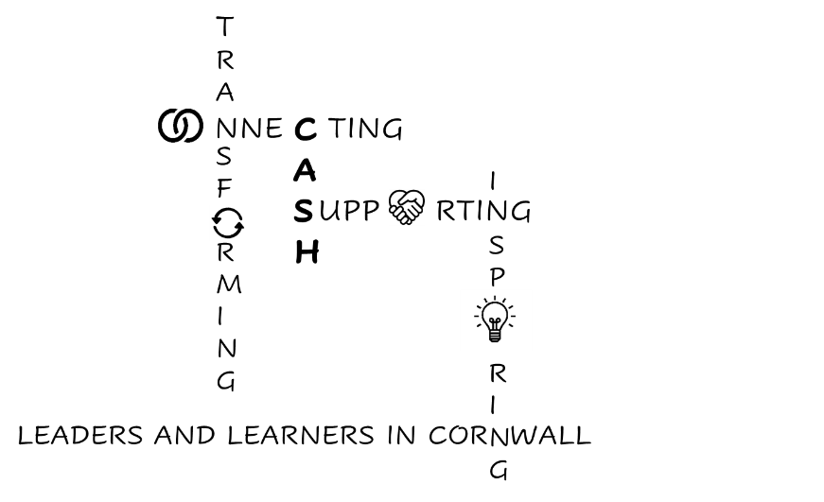
CASH Account
30.01.2026


Dear CASH Colleagues,


CEP: Creative Leadership for Transforming Attendance and Belonging Day

This was a really positive event, with great keynotes from Professor Tanya Ovenden-Hope, Marc Rowlands and Nia Richards (remember, Nia is joining us at our March conference). There are several clear workstreams as a result:
- ‘Team Transtech’: we are exploring ways of improving transport but also options for a more flexible, including digital, offer for those children who have identified attendance barriers. So far, we have organised a meeting with Cornwall Transport and Tanya Ovenden-Hope has contacted Perran Moon to see if he would lobby for a change in the remote learning policy for schools.
- A transition group, looking at strengthening transition across all points from Nursery to Post-16 through a programme running from May ½ term to October ½ term.
- A Parent-Carer communication group.
- A group exploring ways of improving access to provision through community engagement.
Thank you so much for engaging with this event; it was great to see so many CASH schools represented. I’ve uploaded the powerpoints to our website here: Transforming Attendance Keynotes

There are also four work-streams that sit under the SEND Centres of Excellence work:
- An Inclusion Charter Working Party
- An Ordinarily Available Inclusive Provision group
- A Sufficiency Partnership
- Peer Decision Making Panels
I will let you know how you/your SENDCos can be involved as soon as I can.
In other SEND news…


The Local Authority is now providing a couple of advice lines. Full details here: Cornwall Council Advice Lines
SEMH Advice Line – Tuesdays, 9:00–13:00 (Term Time)
Supporting children and young people with SEMH needs can be complex, and having a safe space to discuss concerns or explore next steps can make a significant difference. The SEMH Advice Line offers:
- Universal and whole-class strategies to promote positive engagement and emotional wellbeing
- Guidance and signposting to relevant services and resources
- A reflective space to think creatively about SEMH needs within your school context

The service is available to school staff in Cornwall. It is not a child-specific advice line, and due to GDPR regulations, individual pupils cannot be discussed. No personal notes are stored; however, callers receive a brief follow-up email summarising key points and suggested actions.
The SEMH service works closely with the Educational Psychology Service and the Autism in Schools Team to ensure advice is aligned with wider inclusive support available locally.
To book a slot - SEMH Advice Line Booking Form
For further information, please contact: SEMH@cornwall.gov.uk
Strategic Occupational Therapy (OT) Advice Line – Wednesdays, Afternoons (Term Time)
The Strategic Occupational Therapy Advice Line, led by Occupational Therapist Sophie Roberts, is available to school staff supporting pupils with sensory processing needs and occupational engagement difficulties.
The 25–30 minute sessions offer:
- General, universal advice on sensory processing
- Strategies to support functional and occupational engagement in school
- Signposting to other relevant services and organisations

Like the SEMH line, this is not a diagnostic service and does not replace support from the NHS WRAPS programme or the Autism in Schools team. Due to GDPR, individual children cannot be discussed, and no notes are kept. Each caller receives a follow-up email summarising the discussion and an action plan to support next steps.
To book a slot - Occupational Therapy Advice Line Booking Form
For further information, please contact: sendstrategicot@cornwall.gov.uk


Cornwall’s Autism in Schools Team, along with PINS (Partnerships for Inclusion of Neurodiversity in Schools) are hosting a conference at Falmouth University, Penryn Campus on Tuesday 31st March. Booking is here Social Flourishing conference booking but please let me know if you would like to book, so that I can organise the two tickets for £100 discount. I will send the flyer to your SENDCos. It is also here: PINS conference agenda. I think the Keynotes look really interesting.

Other up-coming events:

Please register your interest here if you would like your students to be involved in Neighbourhood Health and Wellbeing events, organised by NHS Cornwall. NHS Cornwall Neighbourhood Health and Wellbeing events

Kooth have let me know there is a new service to provide free mental health and wellbeing support to parents and carers:

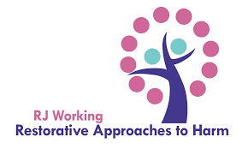
The Restorative Justice Working team is offering an online session on Monday 2nd February between 4 and 6pm to introduce its work around tackling prejudice restoratively. This is contextualised as talking about identity; equipping young people and the adults who care for them with language and principles to talk about many aspects of identity, and to know about and prevent identity-related harm.
This seems very timely as we know that the instances of Hate Crimes have risen by 93% in the west of the county.
Please contact lucy@rjworking.co.uk if you have a member of staff who you’d like to attend.

I have also circulated to your Music Leads information about the Jeremy Huggett Musical Guild Jeremy Huggett Musical Guild which supports young musicians through access to musical tuition, development opportunities & financial support. The application form is here: Musical Guild application form
In the news…
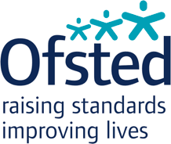
Several Cornish Primaries have now had Ofsted visits. I know that Trewidland (Liskeard) and Nanstallon (Bodmin) were seen last week.


The Government has announced plans to develop AI tutors for disadvantaged students: DfE AI tutors for disadvantaged pupils

The new Government guidance on mobile-phone usage in schools, and the way Ofsted will inspect this is also reported in Schools Week: What does new mobile phone guidance mean for schools?

And guidance regarding suspensions is on the way! DfE on suspensions

Congratulations to Penrice, which has been named in an article in Schools Week as a Lead School in the Government’s new Behaviour and Attendance Hub programme. Schools Week: Attendance and Behaviour Hubs, Lead schools revealed
And linked to this, please remember that the Government’s Universal RISE offer is open to all schools: DfE Universal RISE offer. It has some useful documentation around attainment, attendance and inclusion.
We also have access to specific South West resources and networks;
Disadvantage Network
This network is for leaders of local-authority-maintained schools, academies and academy trusts, and other education professionals.
Areas: Regional
dnicholls@twhf.org.uk
South West Attendance Network
This network is for leaders of local-authority-maintained schools, academies and academy trusts, and other education professionals.
Areas: Regional
Kate.richardson@clf.uk
South West Inclusion and SEND Network
This network is for leaders of local-authority-maintained schools, academies and academy trusts, and other education professionals.
Areas: Regional


Also, locally, there is an exciting opportunity for someone to apply for the role of Programme Lead of the Leading Schools South West SW100 Future Heads programme. It’s 10 days work paid at £600/day. Details are on our website here: Future Heads Programme Leader JD. It closes at 9am on 11th February.


COGS Webinar Wednesday - Wolferstans Solicitors - Managing Parental Complaints
Wed 4th Feb 2026 11:00am - 11:30am
Join Victoria Sargeant and James Twine from Wolferstans Solicitors to get the latest on how to manage a parental complaint and legalities that sit around it.
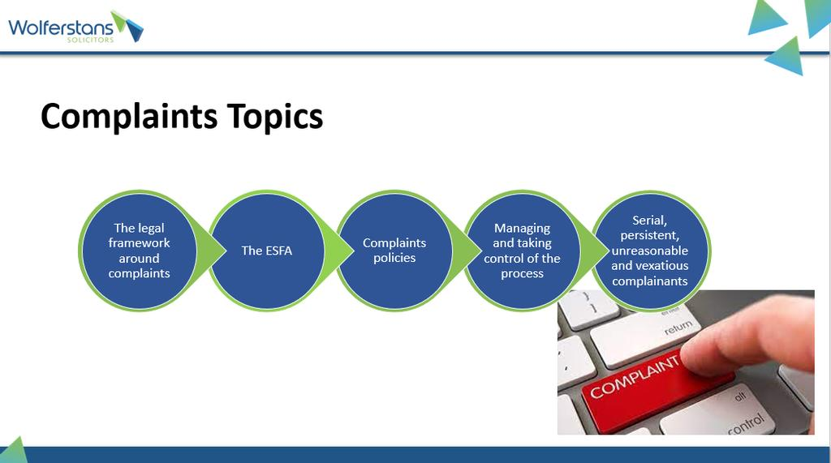_______________________________________________________________________________
Microsoft Teams Need help?
Join the meeting now
Meeting ID: 364 785 012 360
Passcode: Gg6ju2mj

And finally!

CASH March Conference: ‘Creative Leadership for Complex Times’
A reminder that this event is at Lanhydrock on Friday 20th March. I will send out a booking form soon. The day looks like this:
Simon Rowe from Ofsted talking us through changes to the Inspection Framework and sharing insights from the first wave of inspections.
Tom Middlehurst from ASCL on the Curriculum and Assessment Review and implications for school leaders.
A speaker from the Careers and Enterprise Company, around the changes in Careers Education.
Dr Jen Blunden, OBE, CEO of TPAT and Chair of the Cornwall Operations Board regarding using Disciplined Inquiry as a tool for change.
In the afternoon, Nia Richards, Director of Creativity, Culture and Education will help us find our way through all of these changes whilst remaining sane.
Proposed dates for next year’s CASH conferences:
Wednesday October 14th 2026 (confirmed): this is the CEP conference at the Eden Project and will replace our September one.
Thursday 26th – Friday 27th November 2026 for the residential.
Friday March 19th 2027
Friday July 2nd 2027
Our final conference for this academic year is on Friday July 3rd 2026.

The Cornwall Sixth Forms Together Conference is on Wednesday 11th March at Chy Trevail, Bodmin (12.30 – 3pm). If you have a sixth form, then please nudge your Head of Sixth to send me agenda items. Thank you.

I think that’s it. Have a great weekend everyone.

Kate

