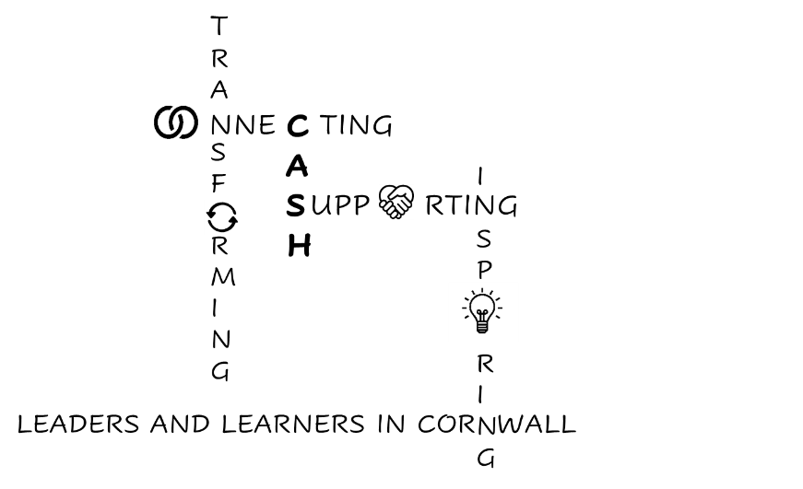
CASH Account
23.01.2026


Dear CASH Colleagues,
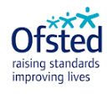
I don’t know if any of you have browsed the Ofsted website to look at the recent inspection reports, but I’m struck by the fact that last week’s published reports for secondaries were all either independent, specialist or boarding provisions; so not much of excitement for most of us yet.
Right, this week:

I had an interesting meeting with HeadStart Kernow around teenage mental health and, as an aside, we discussed how useful it would be if we knew what was triggering most suspensions and exclusions, so that we could do a piece of work targeting the underlying causes (or common factors).
Please let me know if you have spotted any trends.


And on the subject of trends, the Prevent Board meeting raised some interesting trends with regards to Hate Crime in Cornwall (there’s been a 93% increase in West Cornwall over the last year). There has been an increasing number of younger men/boys involved, and they have spotted a trend of the main perpetrators being neurodivergent. This group seems to be particularly influenced by the misinformation and conspiracy theories surrounding the subject of immigration; the impact of the film ‘Adolescence’ on Netflix and Extreme Right-Wing views circulated on social media.
They are hoping to collect intelligence regarding: online activity; the sharing of symbols or ideologies, or any fundraising for right wing causes (often under the guise of collecting for charity) as well as those who are carrying/discussing weapons. Any intelligence is not a Prevent Referral, but a phone call to the Prevent Advice Line please: 0800 011 3764. You can also report using the Safer Cornwall website: Safer Cornwall.
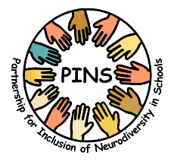
The Neurodiversity Steering Group reported the success of the PINS project PINS project (Partnership for the Inclusion of Neurodiversity in Schools) which has been primary-based so far, but is due to roll out into secondaries this year. School partners were really positive about the access to a range of support and training that is not usually available. So, I’ll let you know when it’s our turn!


The Autism in Schools Team is organising a conference on 31st March at Penryn campus at Falmouth Uni. I’ll forward details when I get them. If we book collectively, we can save money because it’s £75 for one ticket or £100 for two. I will liaise with your SENDCos.
There are also plans to expand support for young people with ADHD, particularly in East Cornwall (Torpoint and Saltash were named, specifically.)

Other things this week.
The Department for Education, in partnership with Ofsted and ParentKind, has published new guidance for parents on how to make complaints. ParentKind has also published a similar guide designed to help schools to respond.

School Guide to Parental Complaints
Parent Guide to School Complaints

Browne Jacobson has some commentary here: Browne Jacobson and Schools Week here: Schools Week parental complaints and there is a CAPH webinar on this topic on Wednesday 4th Feb: Wolferstans Solicitors - Managing Parental Complaints which is free for CASH members.

Also in Schools Week is an article focusing on Ofsted views regarding phone bans: Schools Week: Ofsted to check school phone policies. And here’s an article about a school that confiscates phones for six weeks. Schools Week phone confiscation

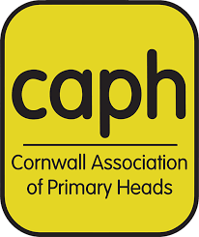
Whilst on the Ofsted theme, CAPH has organised a training session around SEF writing if you are interested. Faye Heming - SEF Writing Workshop in line with the renewed Ofsted framework. It won’t be Primary-specific.

I’ve also understood a bit more this week about the way the Cornwall Educational Landscape fits together:

The Cornwall Education Partnership (CEP)

The Cornwall Education Partnership (CEP) is a strategic, county-wide collaboration that unites representatives from across Cornwall’s education system to agree shared priorities and set the direction for improving outcomes for all children and young people. It is research-driven, values-led, and focused on long-term impact, using data and evidence to understand local needs and guide strategic action. cornwalleducationpartnership.co.uk
Why CEP exists:
- To set shared education priorities for Cornwall.
- To ensure partners work coherently and collaboratively across sectors.
- To use data and evidence to inform strategy and improvement.
- To represent Cornwall’s unique context in local and national policy.

Who Makes Up CEP?
We all do!
CEP is a strategic partnership comprising representatives from key education sectors across Cornwall. Each member brings the voice and priorities of their sector into partnership discussions:
- CEP Operations Board (Chair: Jen Blunden, CEP Vice Chair)
- Cornwall Council (Eveleen Riordan & Graeme Plunkett)
- OneCornwall – Teaching School Hub Partnership (Chris Challis)
- CAPH – Cornwall Association of Primary Heads (Emma Kerr)
- CASH – Cornwall Association of Secondary Heads (Kate Littledyke)
- CACE – Cornwall Association of Chief Executives (Dan Morrow)
- Single Academy Trusts (agreed to be represented via CAPH/CASH)
- The Diocese of Truro (Lee Moscato)
- DfE’s Regions Group (Blanche Duffy)
- Early Years settings (Helen Adams)
- Independent schools (Andy Johnson)
- CEP Operational Board (Jen Blunden)
- Special schools (Guy Chappell)
- Alternative Provision (Rob Gasson)
- Further education & Sixth Form colleges (Martin Tucker)

This broad membership ensures all phases and types of education settings in Cornwall are connected to the strategic conversations shaping how resources, evidence, and priorities are aligned.
Recent Developments: The First Joint Strategy Day
Last week marked the first joint CEP Strategy Day, where members came together to launch the strategic plan structured around five key strands. Work has already begun to deliver on these aims and to connect parts of the wider education system across Cornwall.
Some existing collaborative projects include:
- SEND Centres of Excellence (including a review of Cornwall's Ordinary Available Inclusive Provision)
- Attendance & Belonging Working Group
- Inclusive Education Communities Working Group (which focusses largely on strategies to reduce exclusions and NEET and improve transitions). There’s some great work around literacy coming up.
Some upcoming collaborative events linked to these efforts include:
- Creative Leadership for Transforming Attendance and Belonging - Tuesday 27th January (and this will have follow-up online sessions with Marc Rowlands on 10th March and 7th May)
- CAPH & Diocese Spring Conference 2026 - Transforming Inclusion - Wednesday 18th March
- CASH Spring Conference - Friday 20th March – where Dr Jen Blunden will be talking about the Inclusive Education Communities’ work and the concept of Disciplined Inquiry.
- CAPH & CASH SEND and Inclusion Network Meeting - Wednesday 10th June
- Cornwall Headteacher's Autumn Conference - Wednesday 14th October (CAPH, CASH & Diocese)
These events and activities help build coherence and partnership across Cornwall’s education ecosystem, supporting transition, reducing duplication, and improving outcomes for children and young people.
A separate ‘thread’ seems to sit under the SEND Board (also with a broad representation, including us). Several groups I attend, such as the Mental Health Steering Group and the Neurodiversity Steering Group report into this group. These are chaired by the Rochelle Bones, the Deputy Programme of Care Lead - Maternity, Children and Young People for NHS Cornwall and Isles of Scilly Integrated Care Board.

One Cornwall coordinates training and has lots of great stuff on the website including free CPD. One Cornwall free CPD.
There is lots around SEN and Inclusion, Becoming a Neurodivergent Friendly School: Autism, ADHD and PDA
- Emotionally Based School Avoidance
- An introduction to the PACE Approach for use with pupils with SEMH Needs
- Pastoral Network
- Other online CPD including recordings of previous Pastoral Network webinars

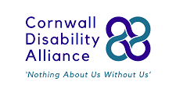
Cornwall Disability Alliance has launched - Your Voice Cornwall, a BIG health, disability and inclusion countywide survey designed to understand the everyday experiences of people living with health conditions, disability or who have access needs across Cornwall and the Isles of Scilly. Please encourage any young people with disabilities to complete this survey: Your Voice Cornwall survey. There’s a chance of winning £500!

I’ve also been asked whether anyone would be interested in the following school uniform survey:
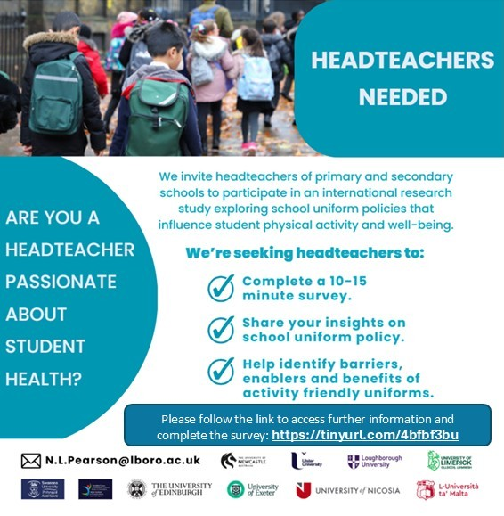
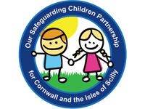
Another group I attend on behalf of CASH is OSCP (Our Safeguarding Children Partnership). OSCP
Our Safeguarding Children Partnership (OSCP) is the key statutory mechanism for agreeing how relevant organisations will work together to promote, safeguard and protect the welfare of children and young people across Cornwall and the Isles of Scilly.
The members of the OSCP work together to safeguard children in Cornwall and the Isles of Scilly. They also provide assurance that the arrangements are effective to bring about good outcomes for children.

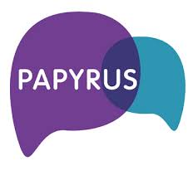
Following recent local events, Kate at the Papyrus Foundation has reached out with some information and training around suicide prevention: Papyrus video. Please let me know if you would like Kate to come in and talk to your staff/students. More information on their website: Papyrus UK

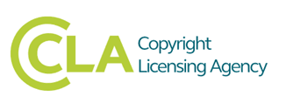
And in other news:
Graeme Plunkett has asked me to bring to your attention, the visit to Cornwall by the Copyright Licencing Agency in the summer term to audit a selection of schools. We do not know yet which schools will be in the sample, but the letter below gives an explanation of the context and what will transpire for those that are when the time comes.

Dear Head teacher/Principal,
  - Re: CLA Collection of Royalties Data - Photocopying, Scanning & Digital/Website re-use of Published Material
  - I am writing to advise you that The Copyright Licensing Agency is intending to conduct a data collection exercise in selected Cornish schools/academies during the summer term 2026.
  - This will enable CLA to establish what is being photocopied/scanned and/or digitally re-used so that your licence fee can be fairly redistributed as royalty payments to the authors, artists and publishers of the licensed material you are using. All state-funded schools, including academies, hold a CLA Education Licence arranged through central agreements or regional education bodies, such as the DfE, WLGA, Scottish Government and the Education Authority.
  - Your CLA Education Licence also includes digital rights so, in addition to photocopying and scanning permissions, schools are able to re-use digital publications covered by the CLA licence, such as e-books and certain website content. Further, the NLA Licence for newspaper copying, which is managed by CLA, provides many schools with permission to copy/re-use printed and digital content from NLA licensed material. Information on the NLA licence can be found here.
  - In accordance with the current terms and conditions of the Licence, the school and all staff are required, when requested, to participate fully in any such data collection exercise.
  - If your school/academy is selected, you will receive an explanatory letter from CLA followed by contact from a CLA representative who will explain the procedures involved. CLA is aware of teacher workload issues affecting all schools and have refined their collection procedures accordingly, which include moving to a remote model and eliminating school visits.
  - This exercise will begin just after the start of the term and lasts no more than 11 weeks. All schools are required to start and finish the exercise at the same time to ensure robust sampling. It should be noted that this exercise is not a compliance initiative though participation is mandatory.
  - The purpose of this letter is to give you advance notice of the data collection and selected schools/academies should direct any questions to myself or to the CLA representative.

  - Yours sincerely

  - 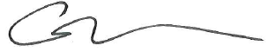
I will let you know if I get a whisper of which schools will be visited.

  - And I found this item in Headlines interesting!
  - Education shapes UK political views, study finds
According to a report by the National Centre for Social Research, education significantly influences political views in the UK. Individuals with qualifications below A-level are over twice as likely to support the Conservatives or Reform UK compared to those with higher education. The study found that 55% of people without A-levels oppose allowing undocumented immigrants to stay, while only 36% of degree holders share this view. Alex Scholes of NatCen stated: "In Britain, education stands out as the most important dividing line, particularly on immigration and diversity."
Daily Mirror
So let’s keep our kids in education!!

  - And here’s a fantastic free event to end with a smile:

Fantastic Foxgloves!
Bring your group to Kurt Jackson's new Spring/Summer exhibition...

Spring and summer are the perfect time to bring your school or college group to artist Kurt Jackson's NEW exhibition 'Foxglove'!
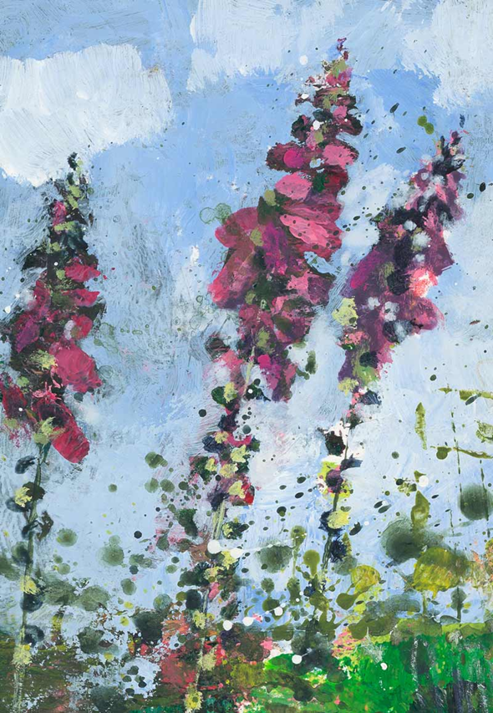
Book your 2 hour art workshop for up to 30 students (Tuesday - Friday during term time).
Possible curriculum links for this exhibition:
Art - drawing, painting, sculpture, colour, texture, line, shape, form and space (to name but a few!)
Science - plants: pollination, adaptation, parts of plants, plant uses in medicine
Poetry - inspiration for writing using Kurt Jackson’s poems and paintings of the Cornish landscape
Folklore - storytelling and art, Cornish folk tales
All sessions include a curriculum linked art activity that takes inspiration from the work of world renowned artist Kurt Jackson, combined with a cross curricular objective of your choice.
All materials are provided and the sessions are planned and led by our experienced Education Officer Rachel.
These sessions are FREE for Cornish state schools and you can book more than one per school to fit the size of your cohort.
For more information see our website
To book email Rachel: education@jacksonfoundationgallery.com

Have a wonderful weekend everyone.

Kate

